JMeter Tutorial

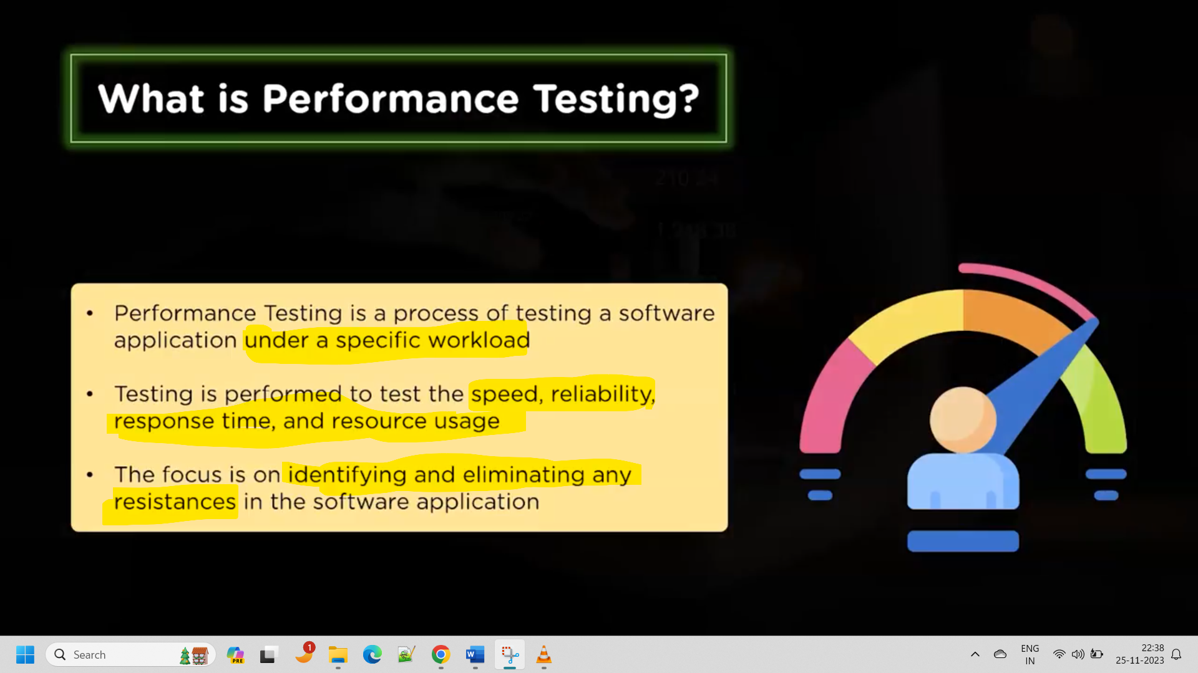

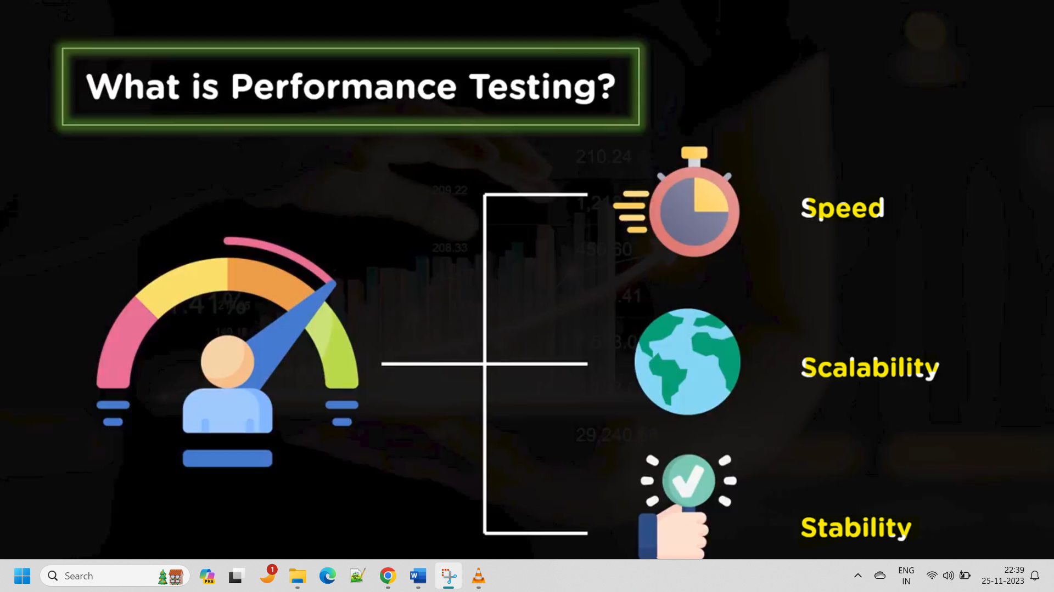

Scalability: identifying the maximum load capacity

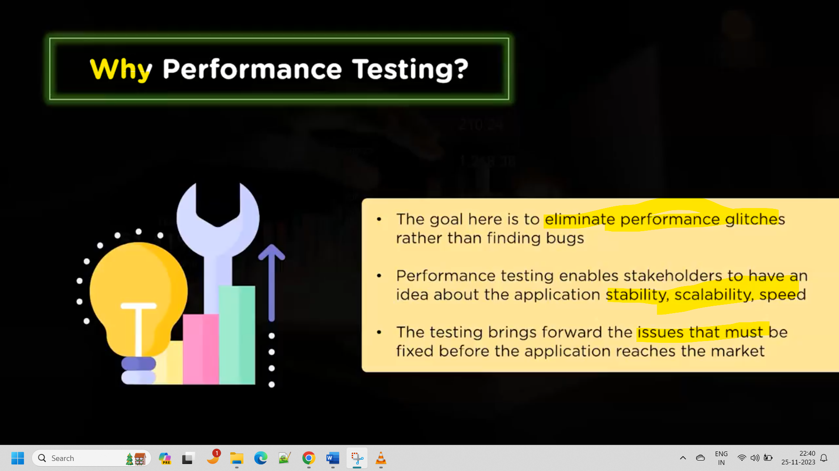

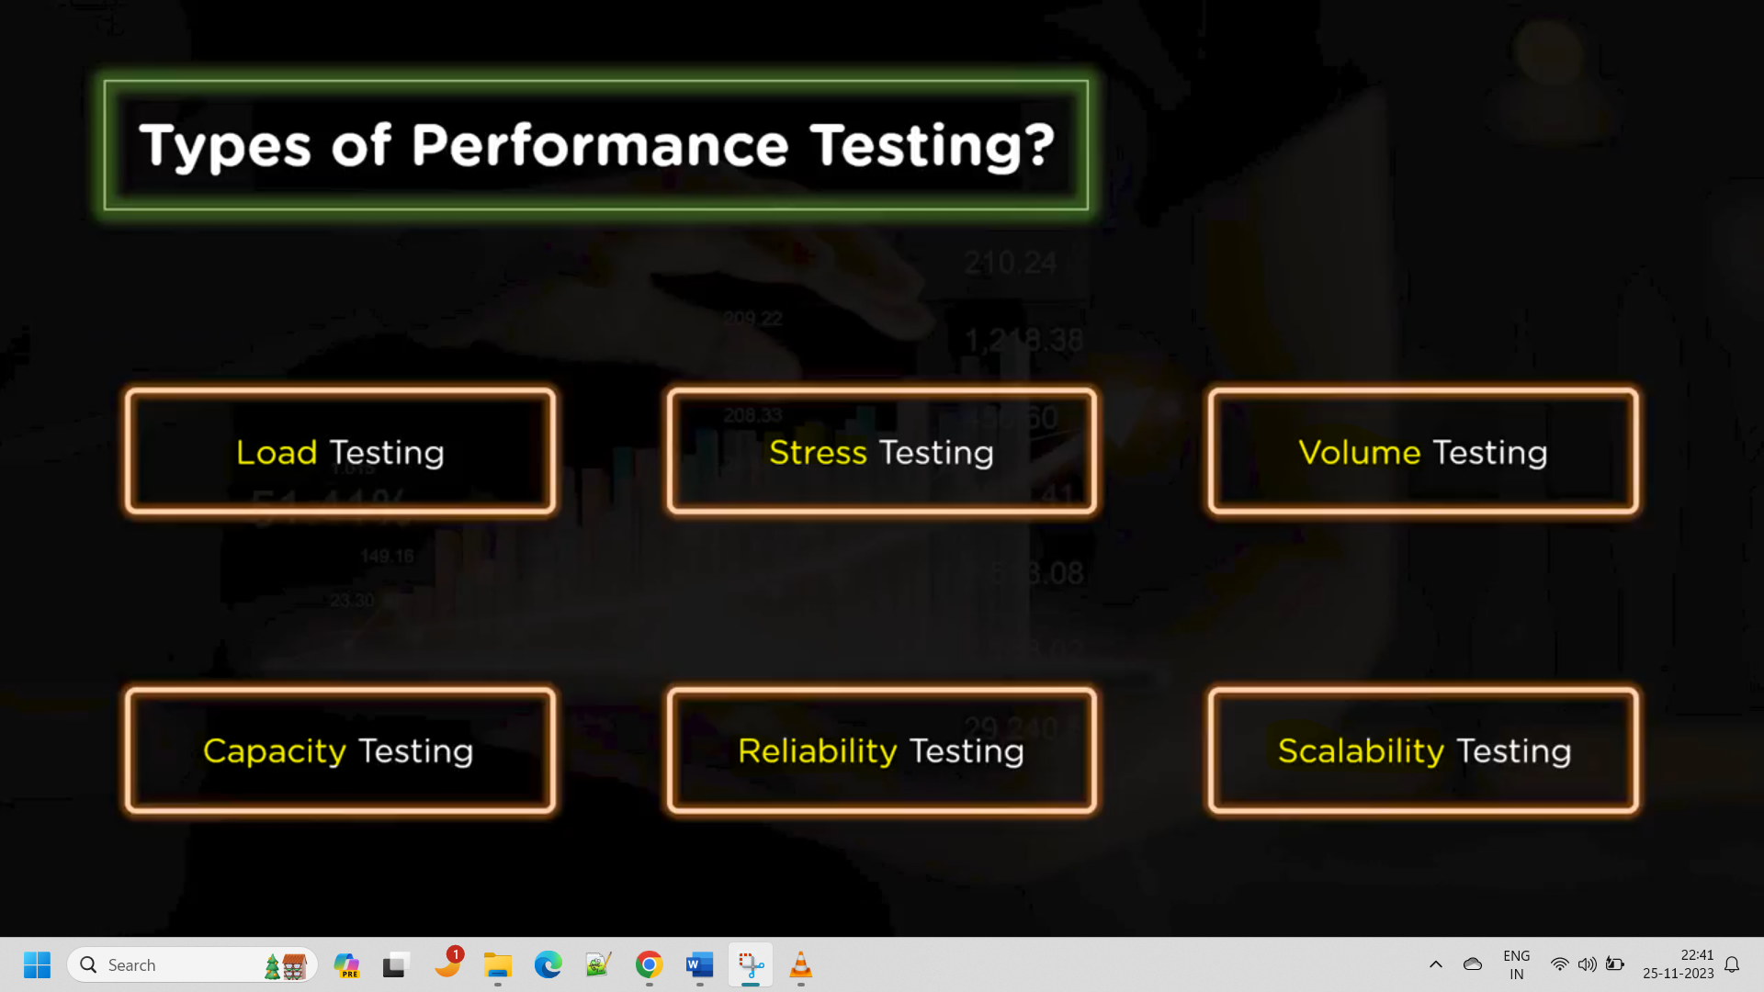

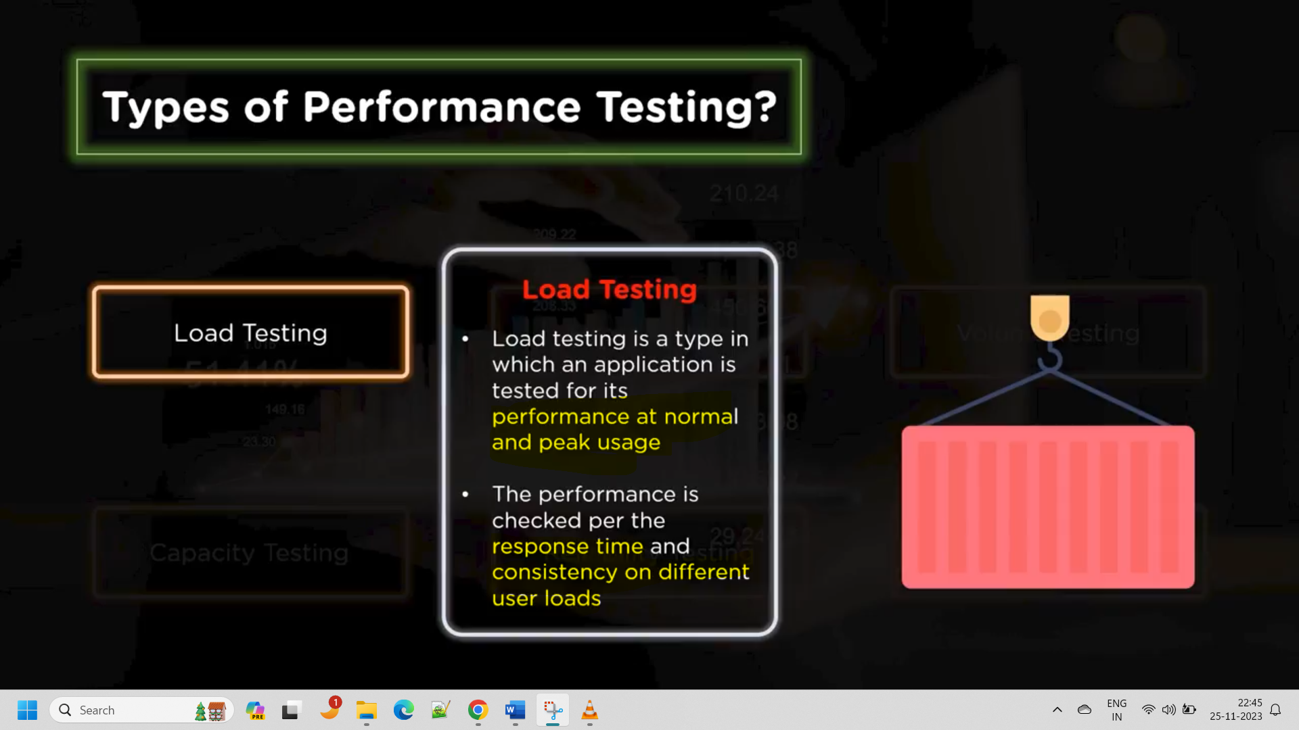

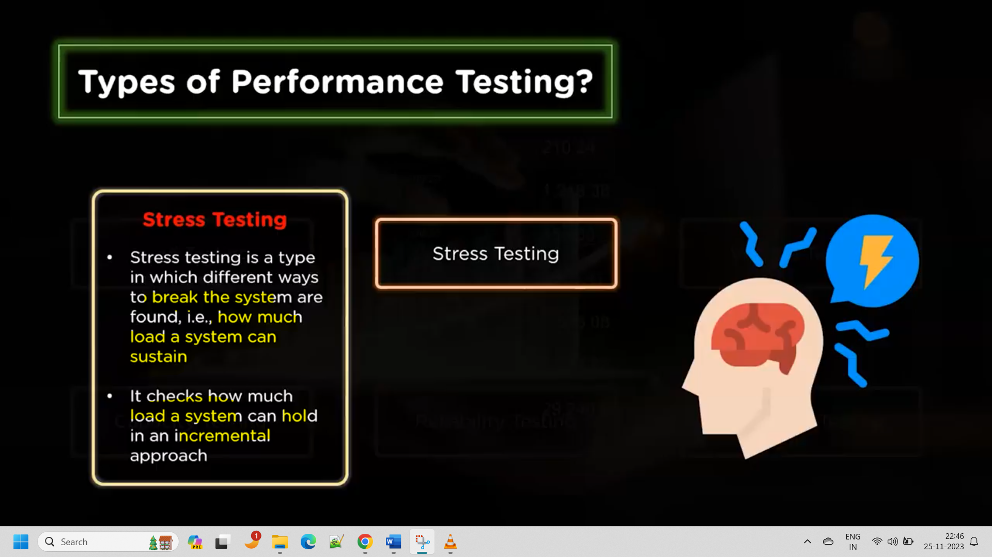

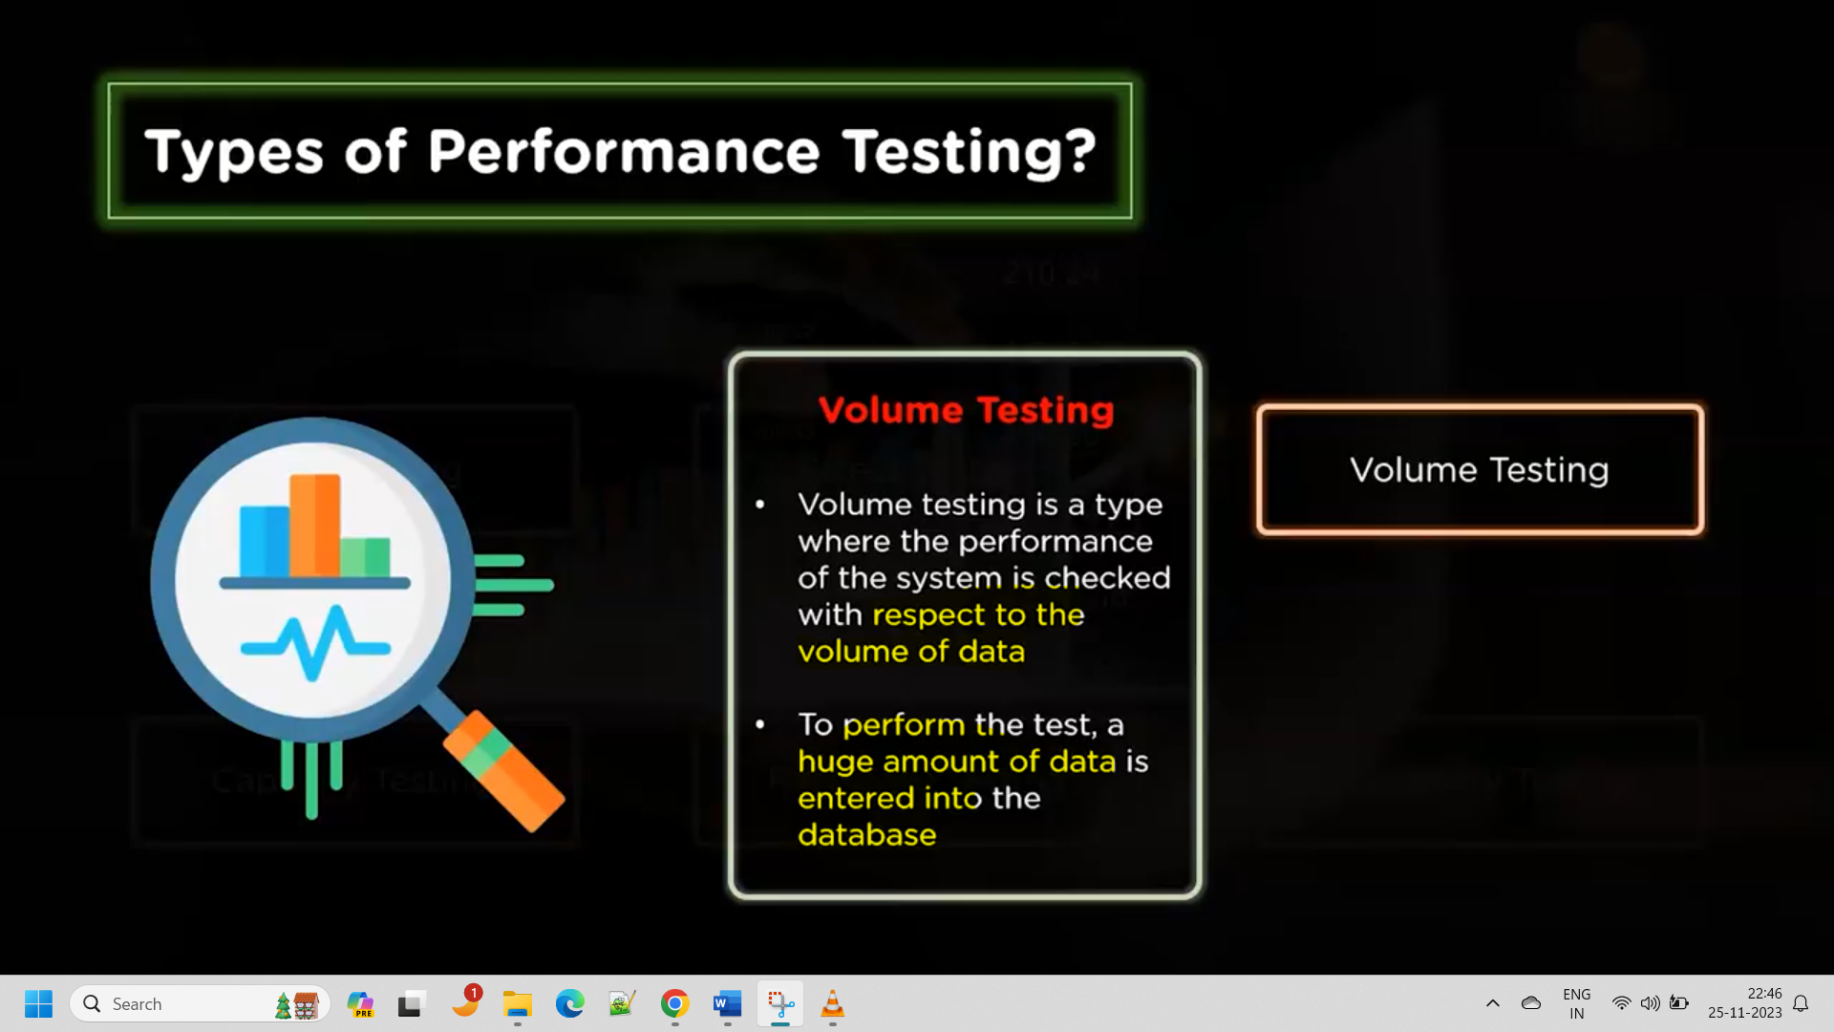

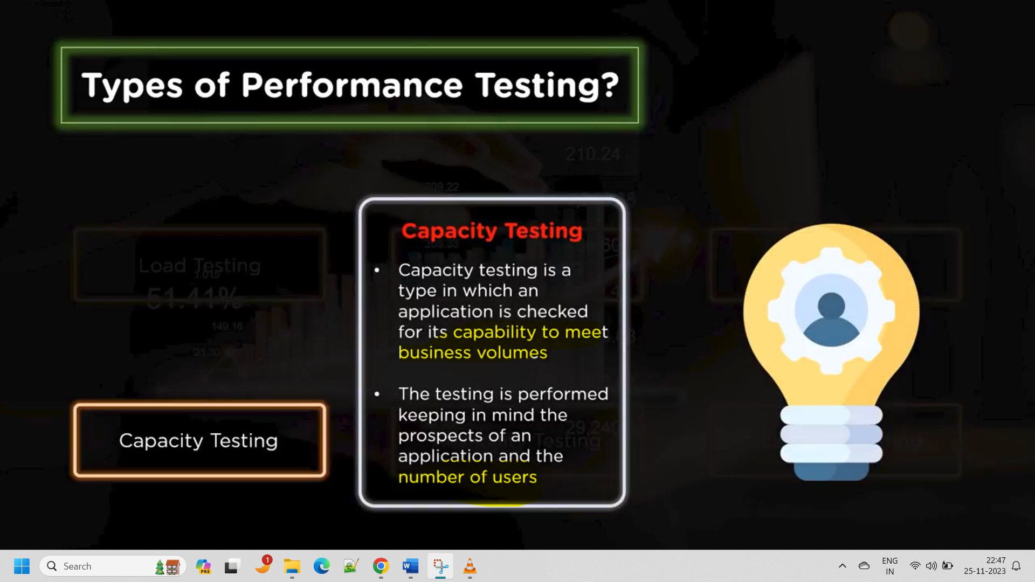

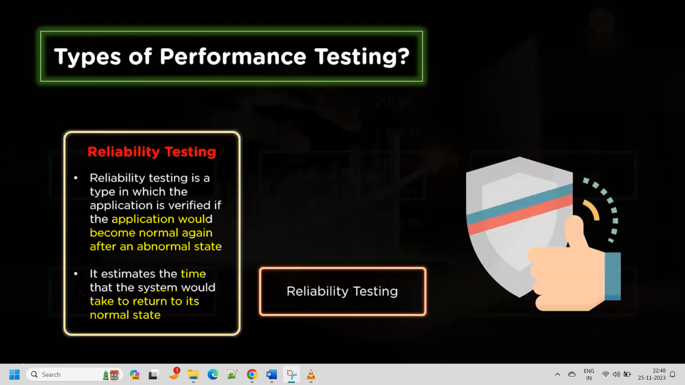

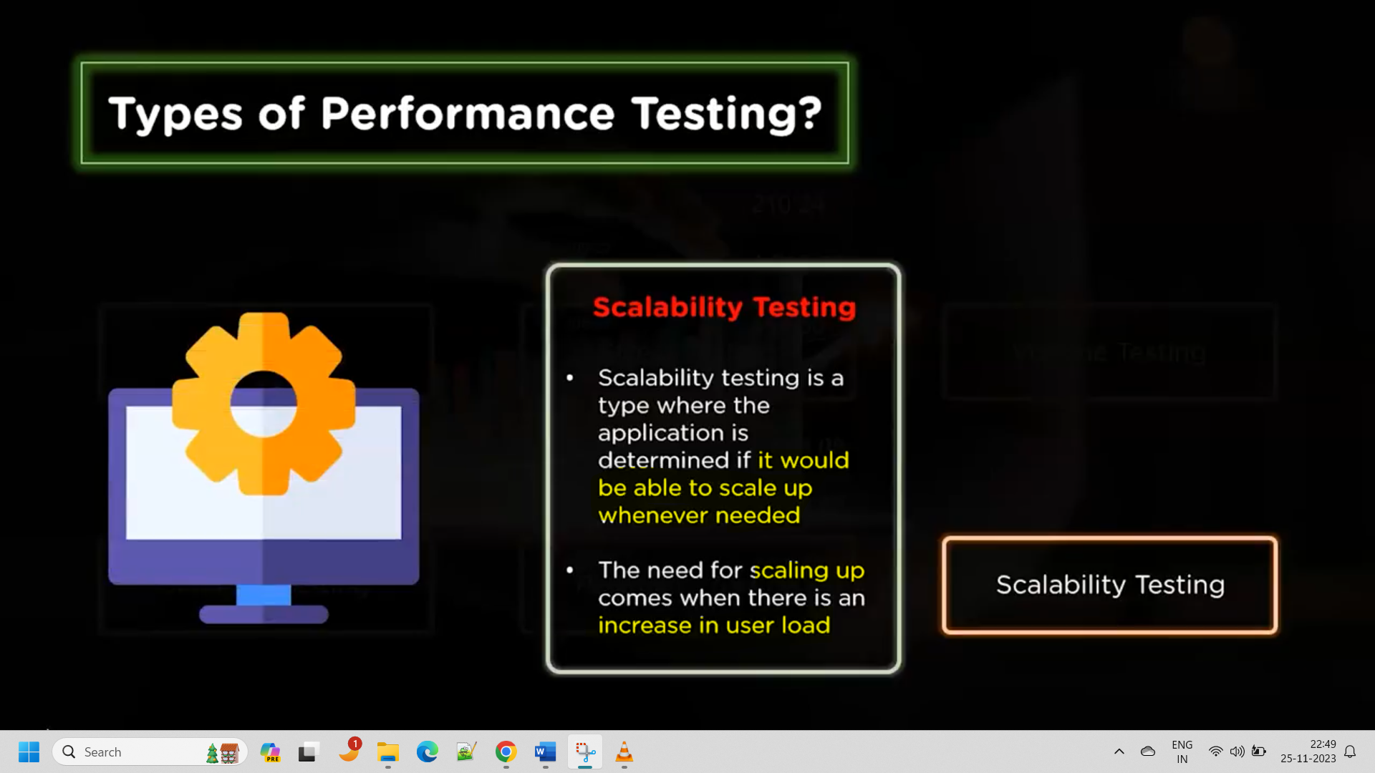

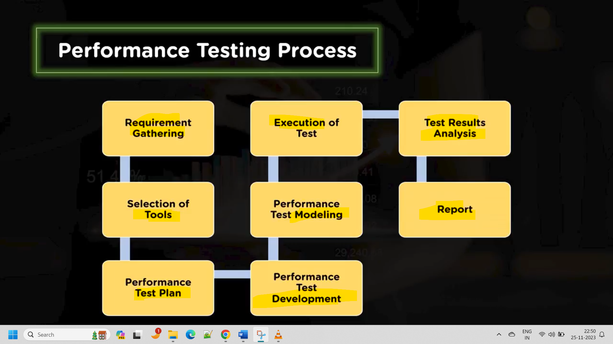

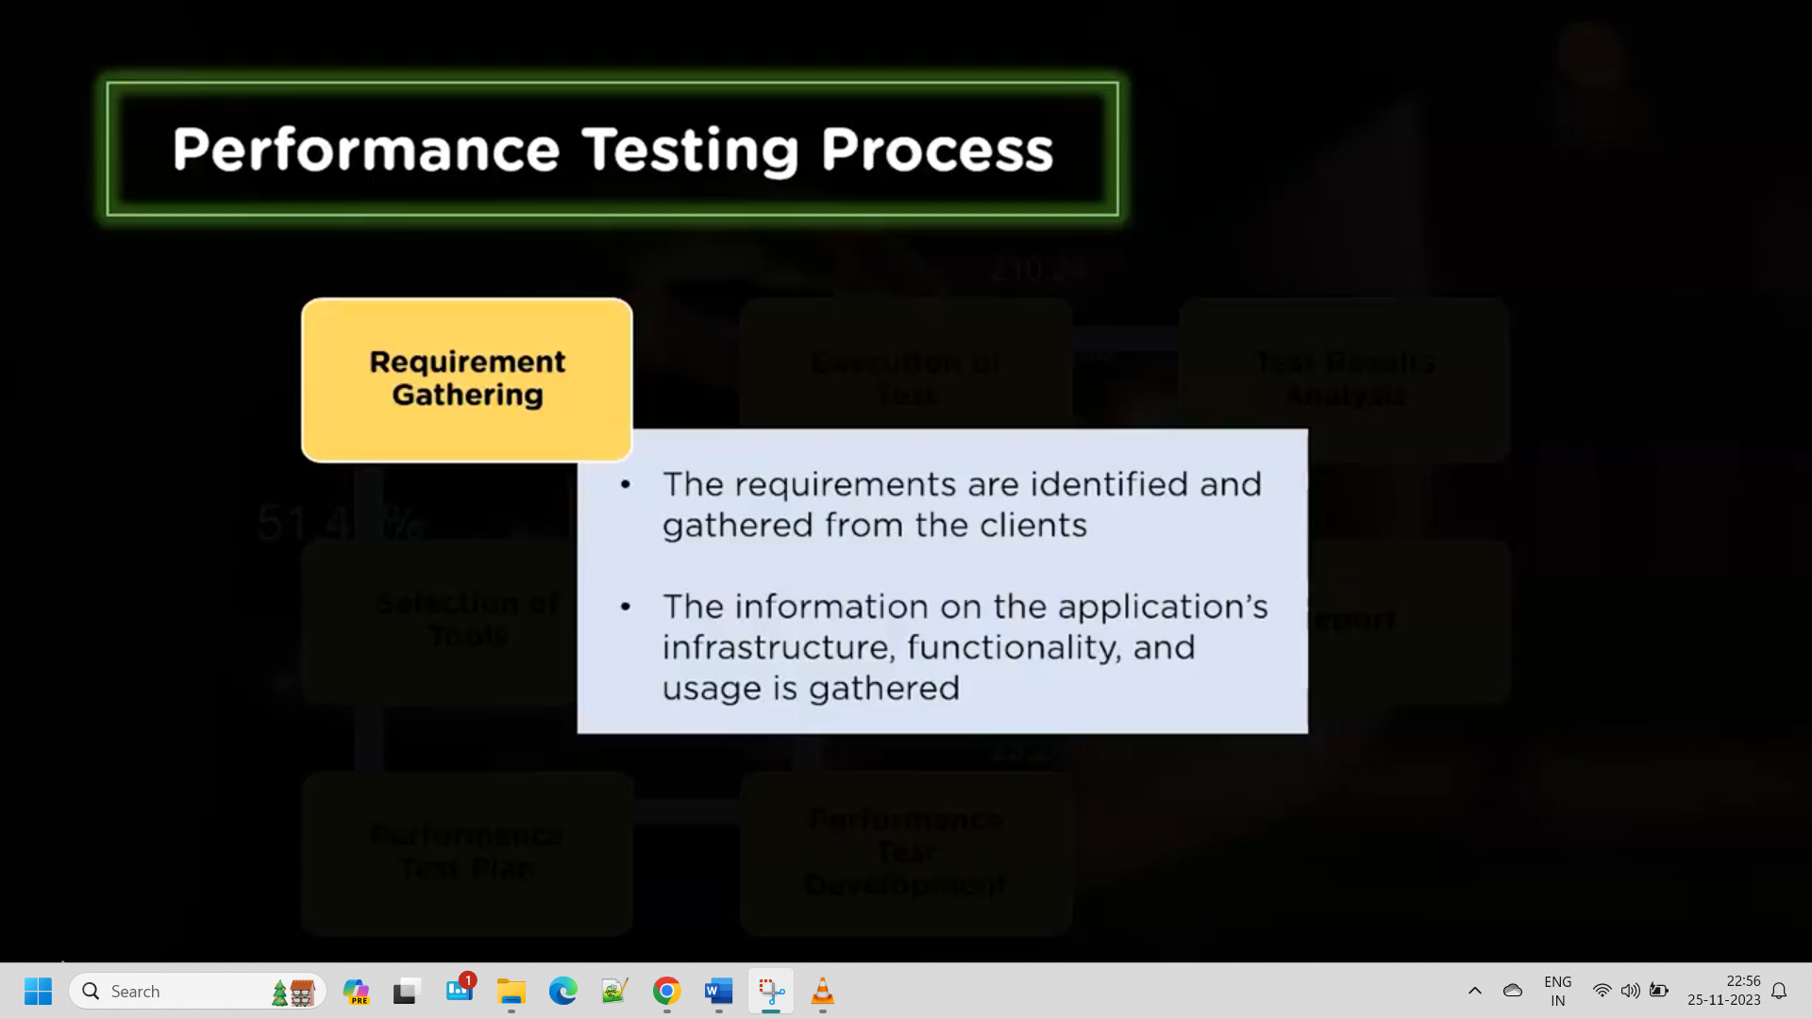

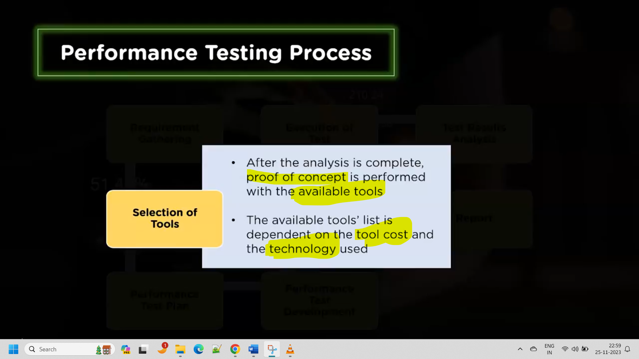

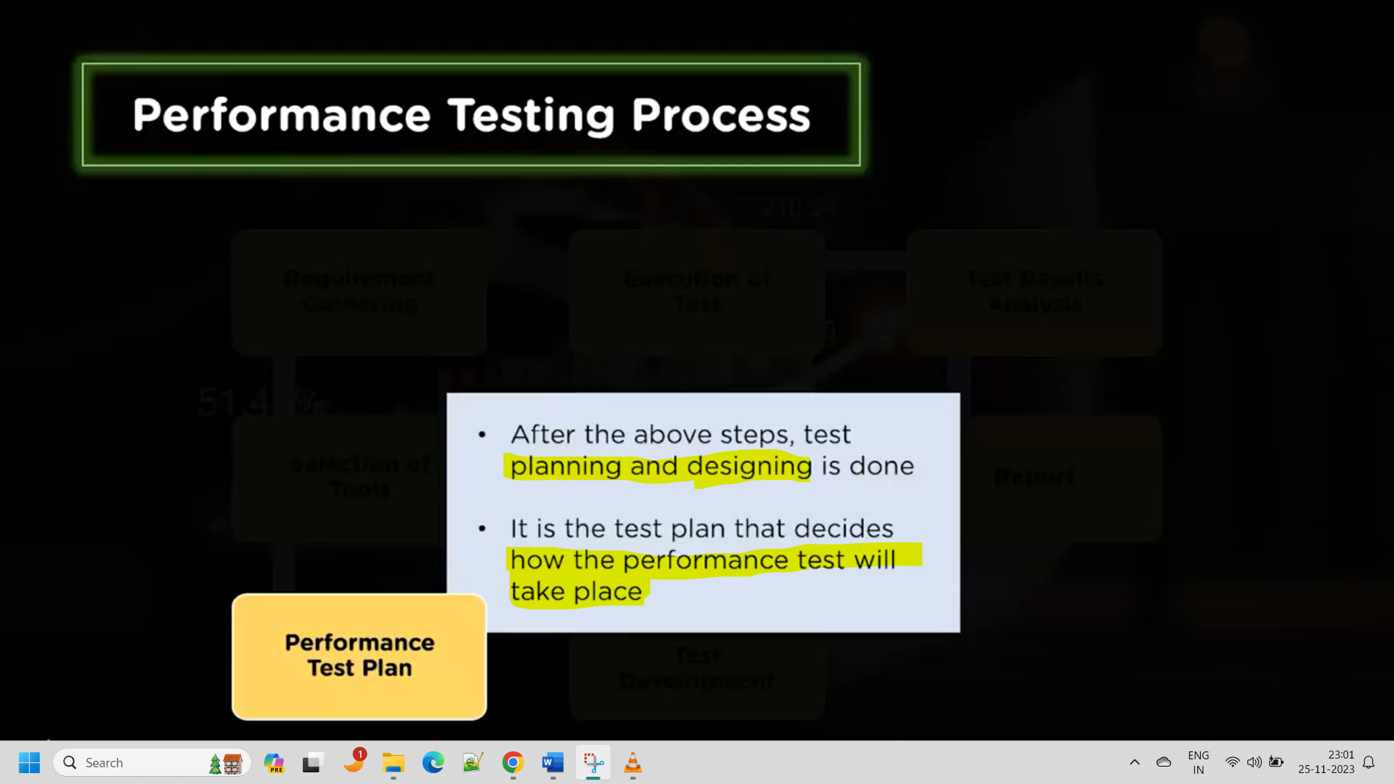

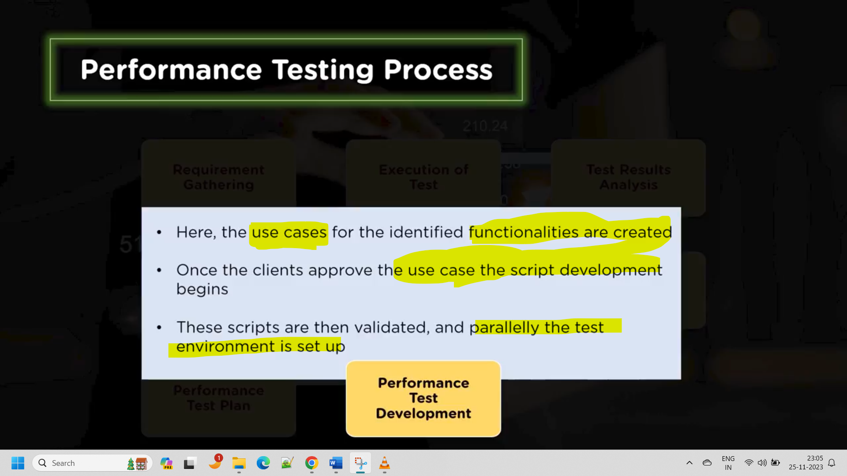

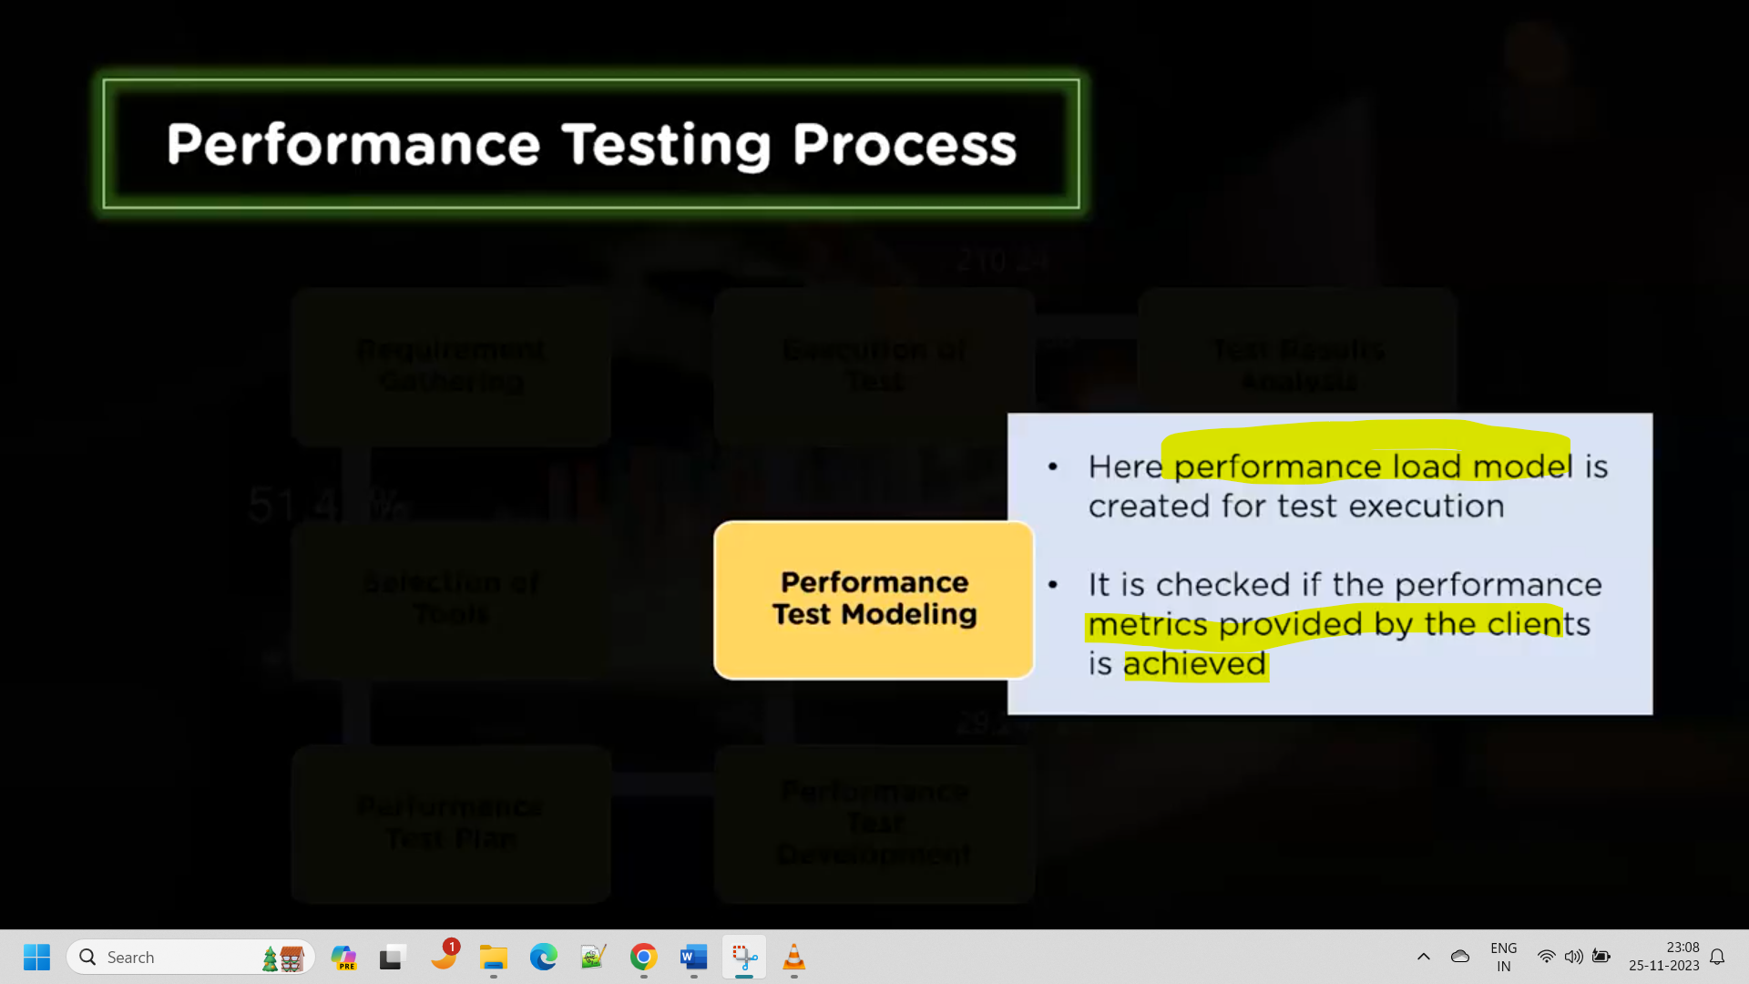

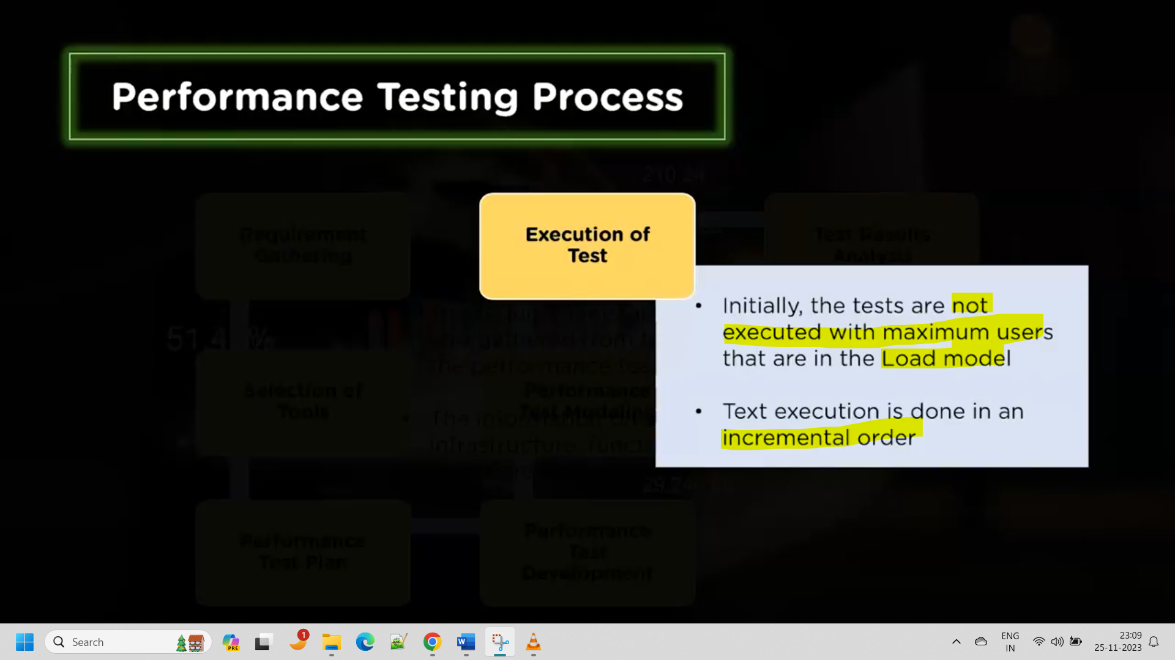

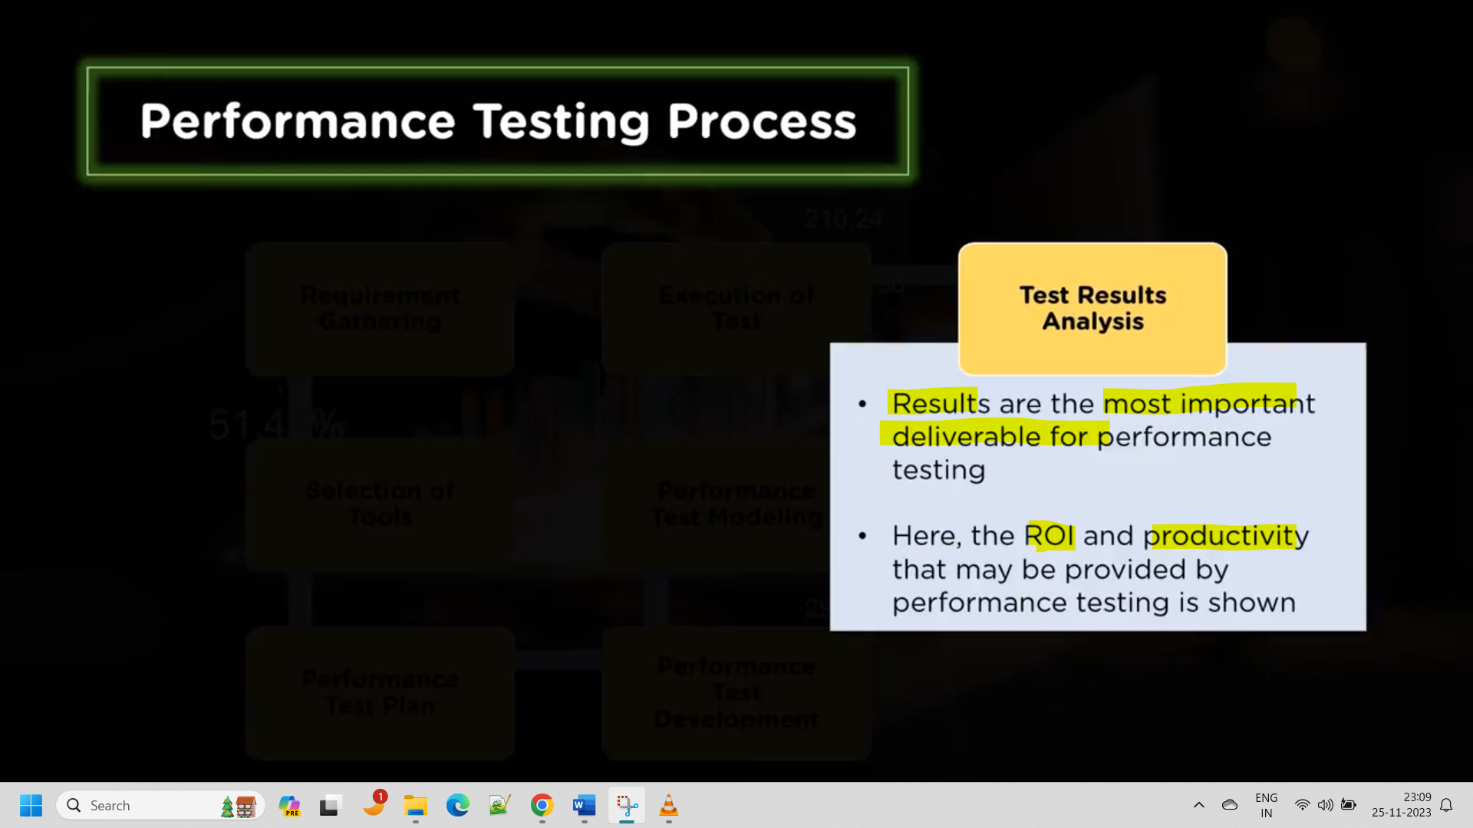

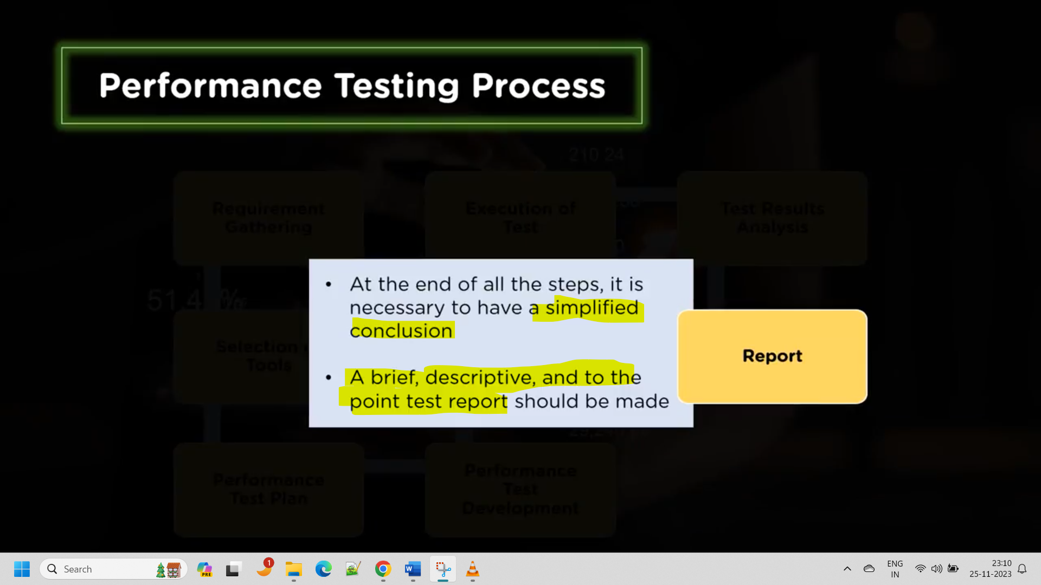

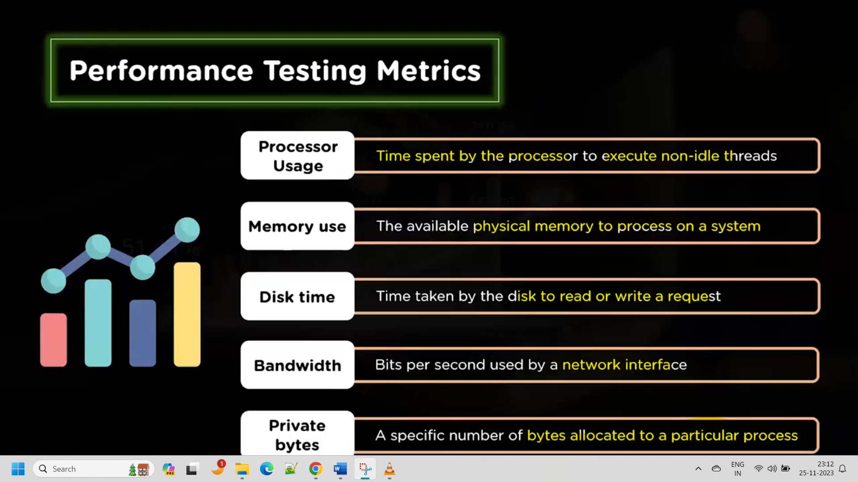

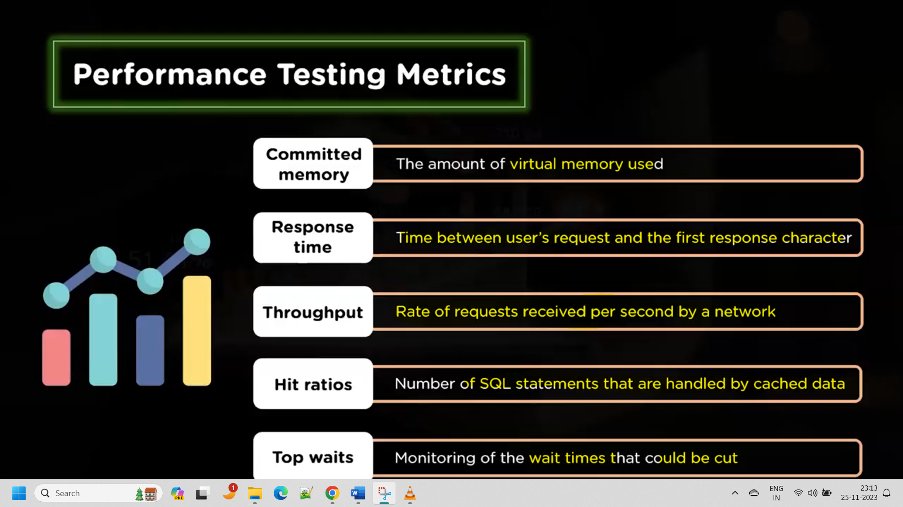

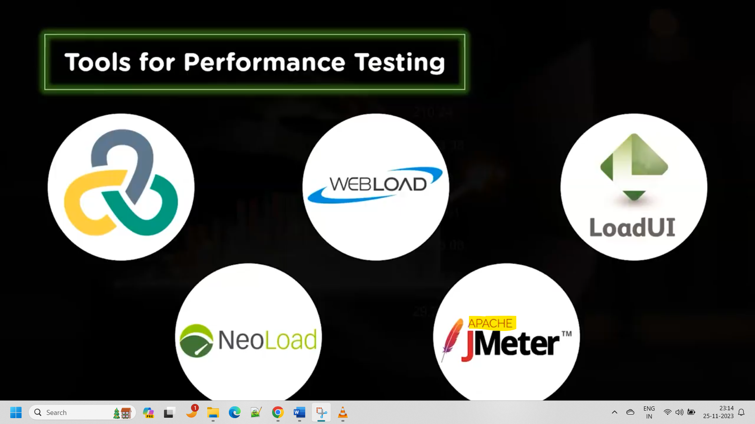

1st one HP Load Runner.

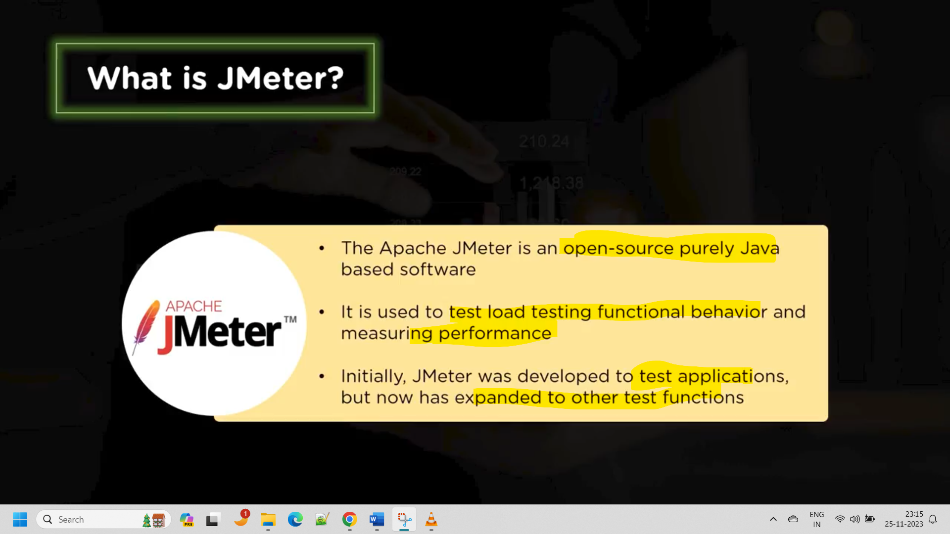

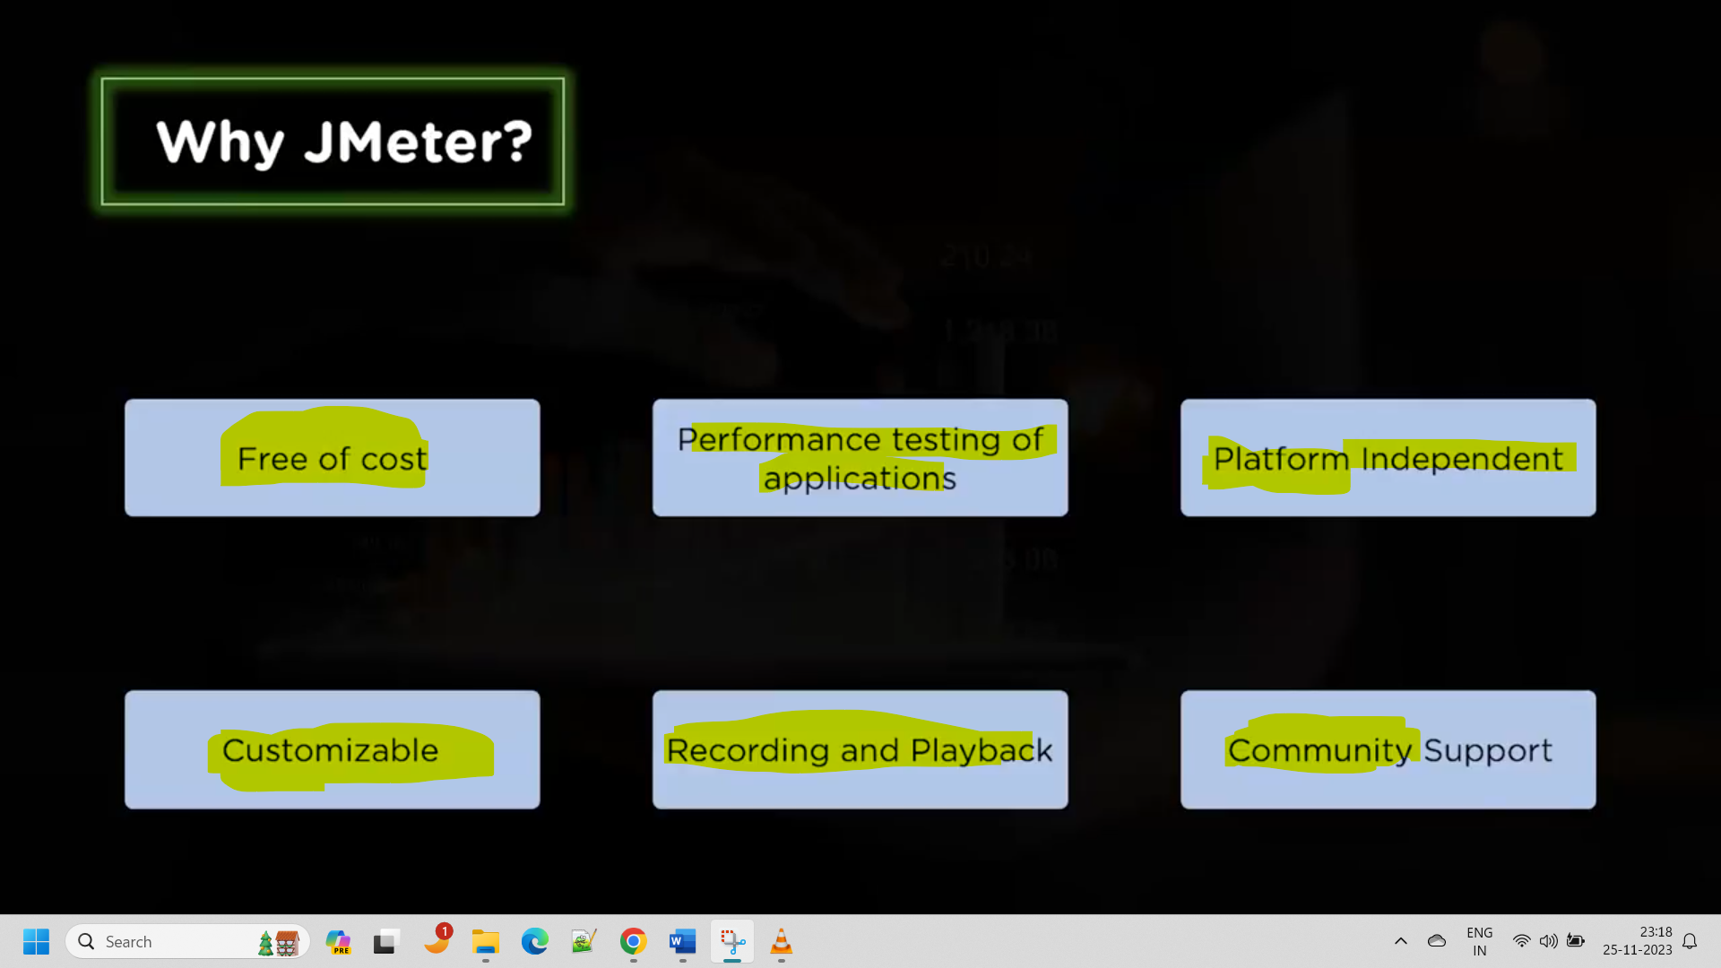

Download the Jmeter application and open it from the bin folder that is bat file as it wont have the desktop shortcut.

1. Create a test plan(similar to project)
2. Add the thread group

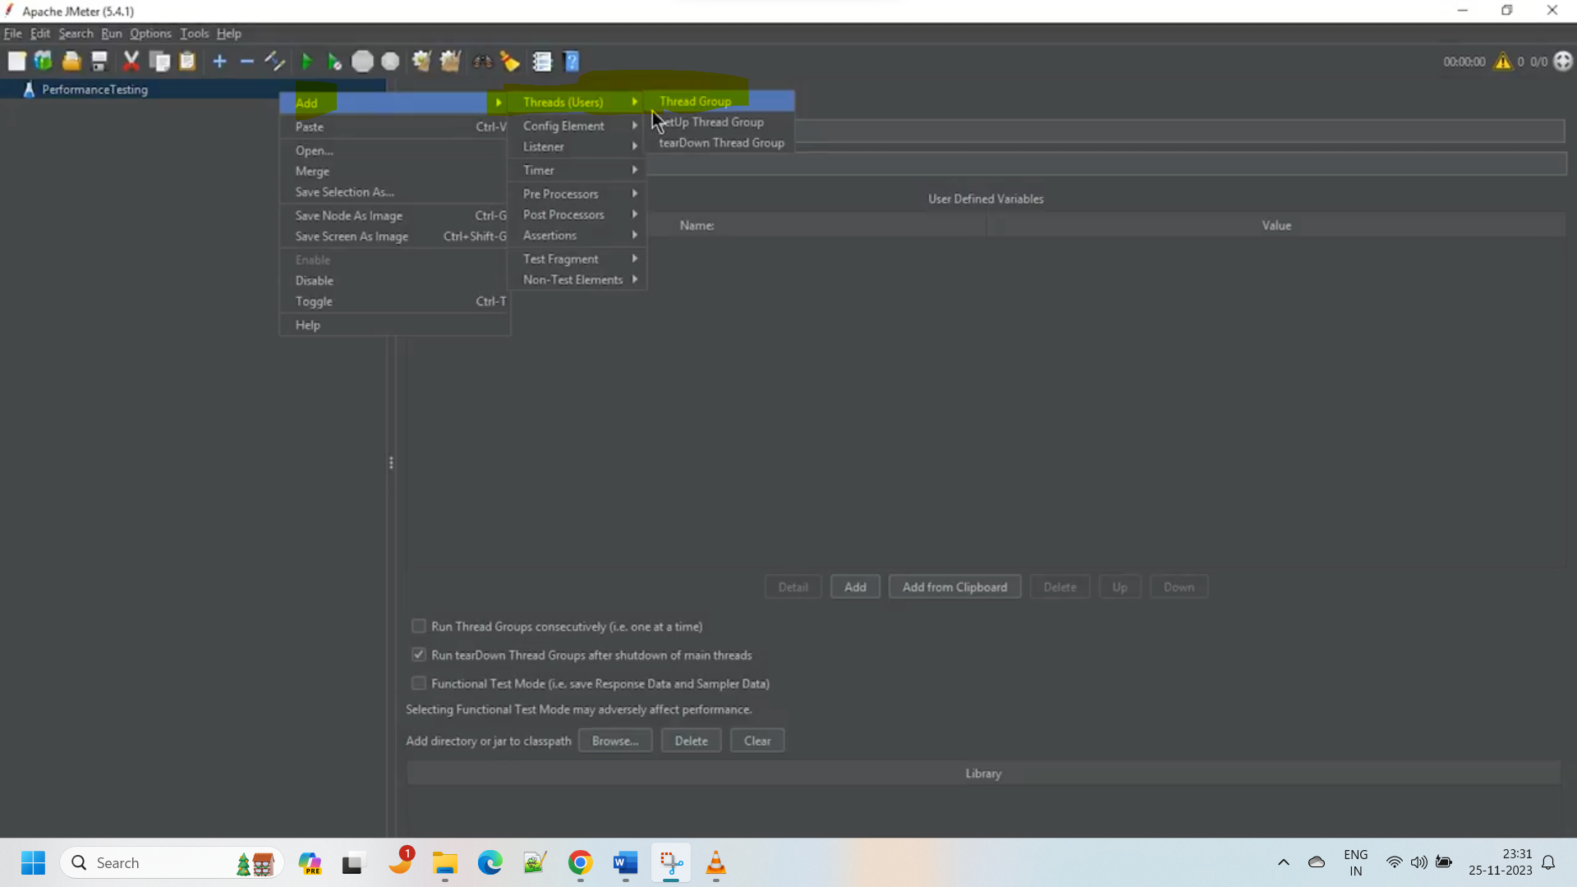

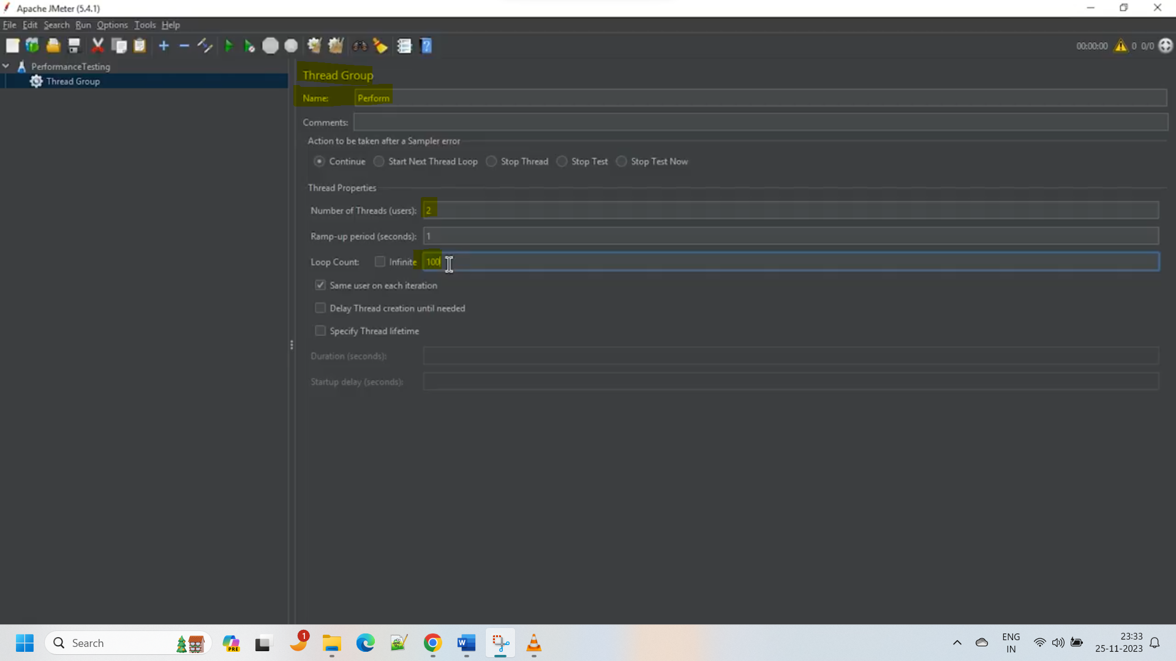

1. Add the HTTP sampler

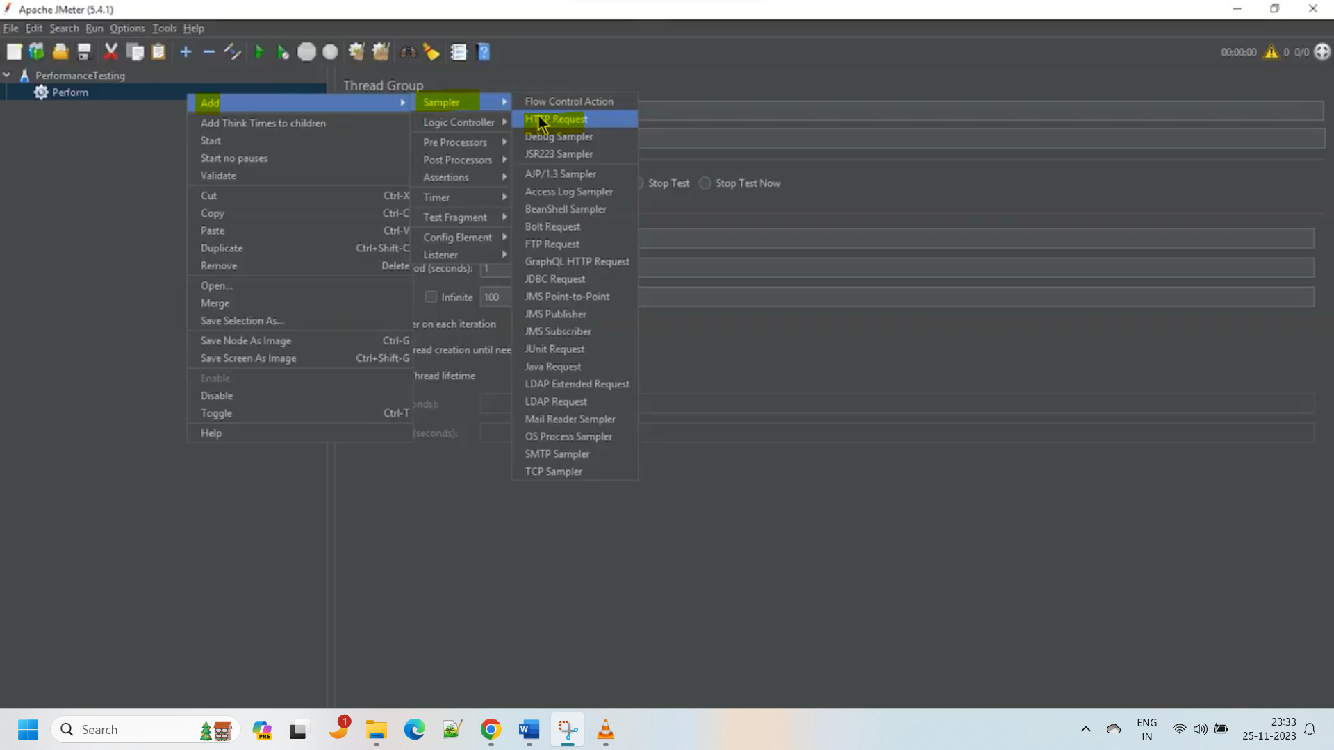

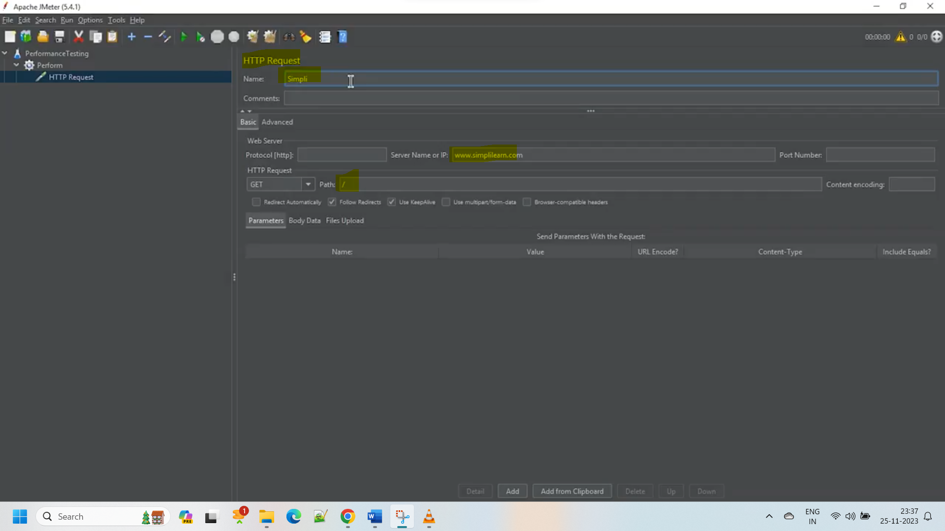

1. Add the listeners to get/view the results

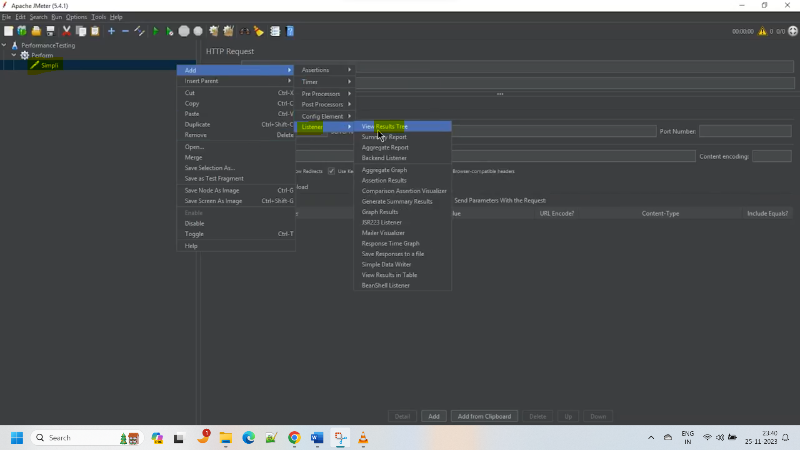

Above listener is to view the results in tree view

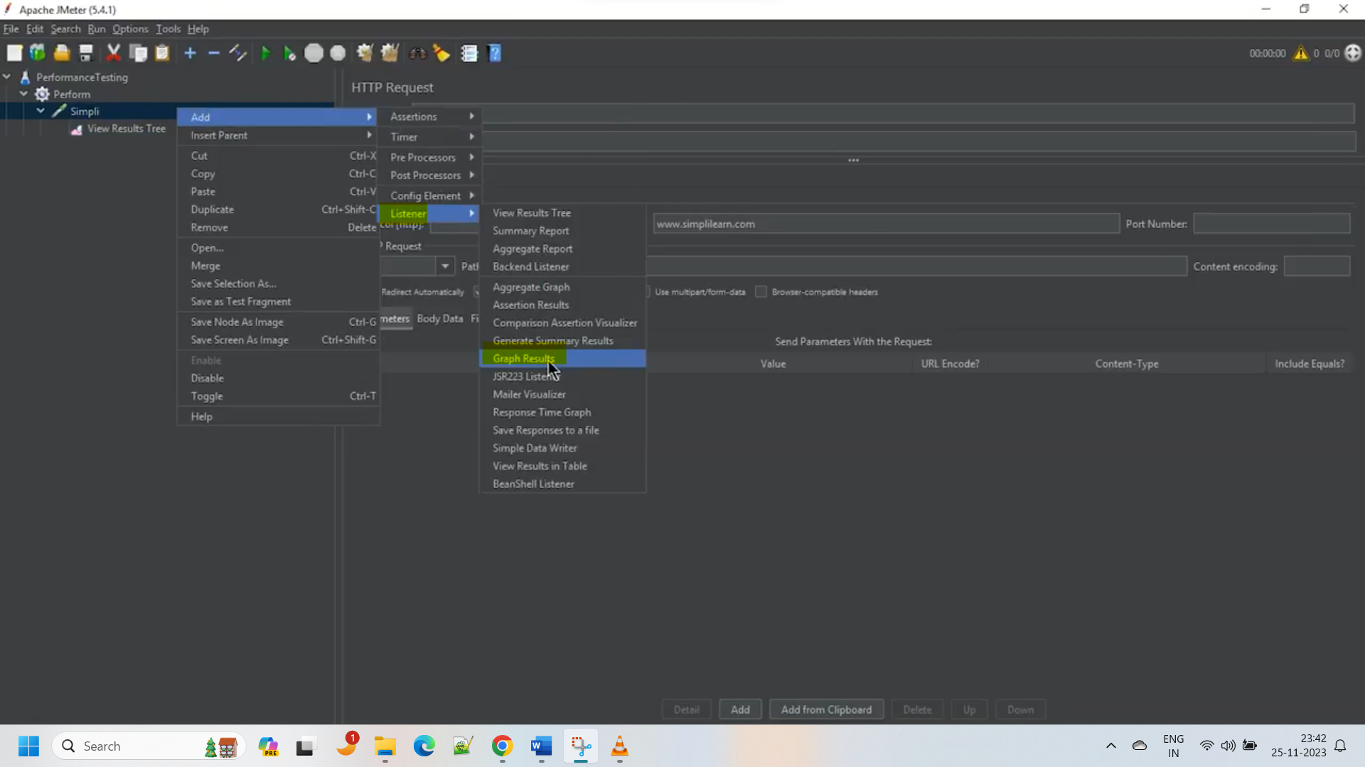

Above listener is to view the results in graph view.

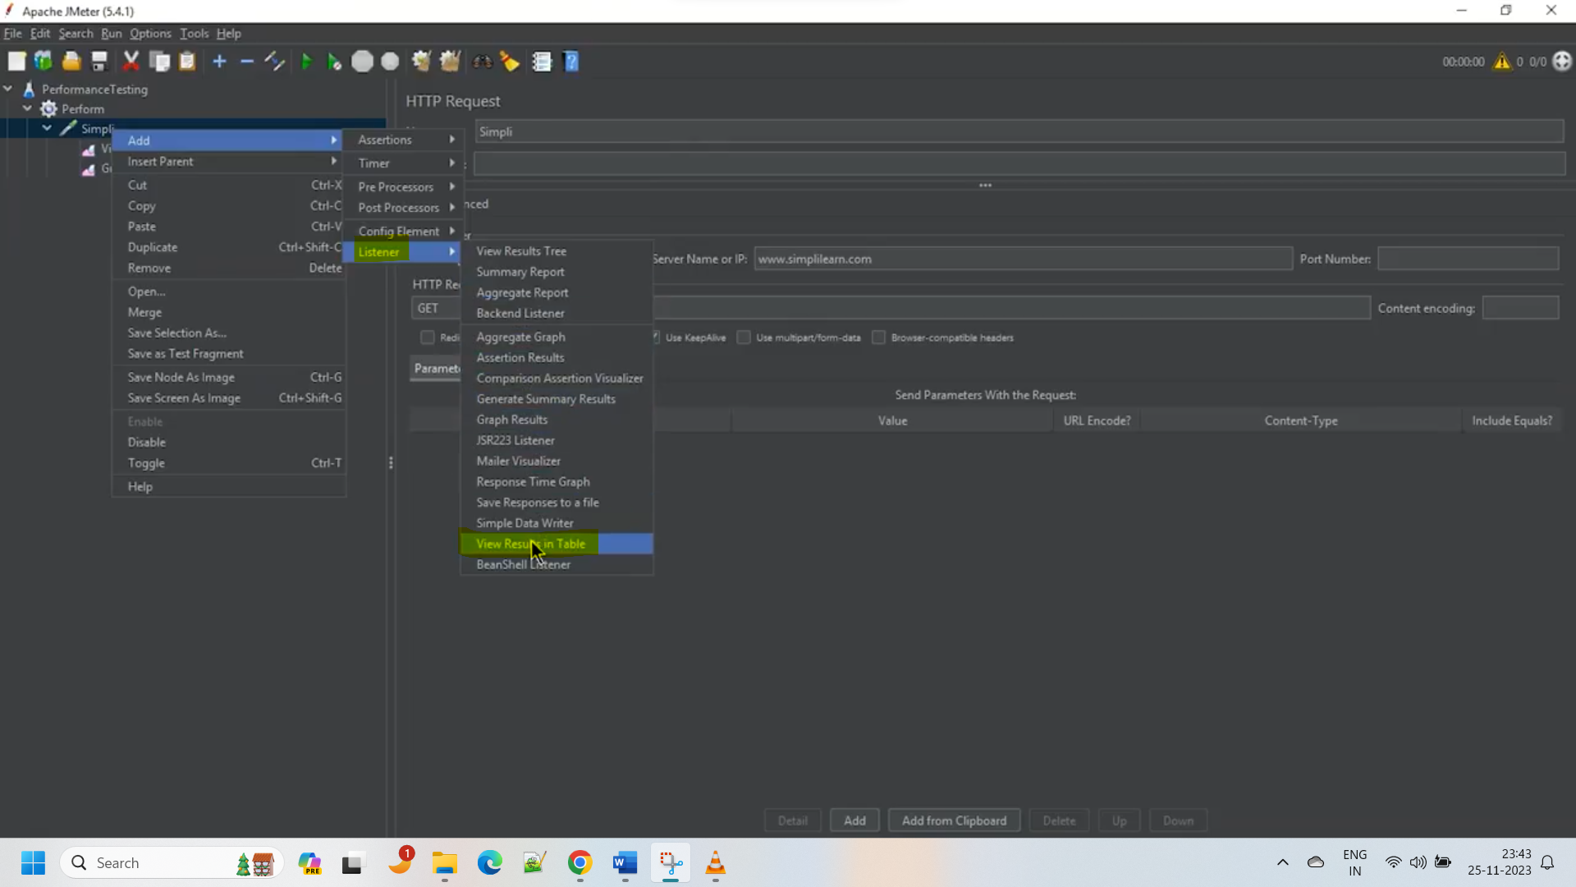

Above listener is to view the results in table view

1. save and run the test

file will be saved as .jmx format

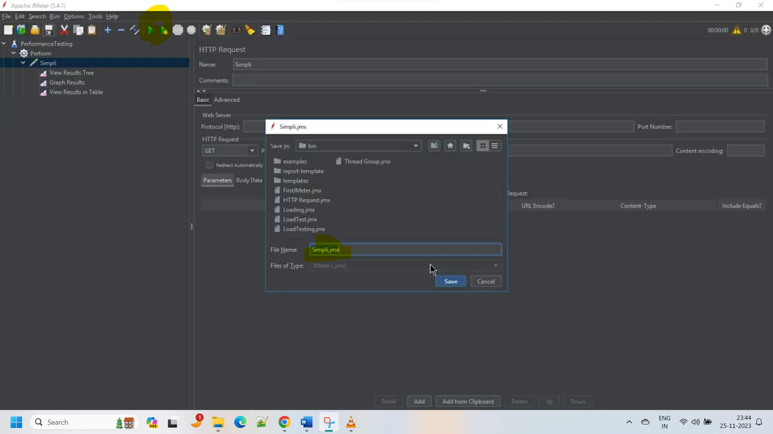

1. In the different listeners we can see the results.

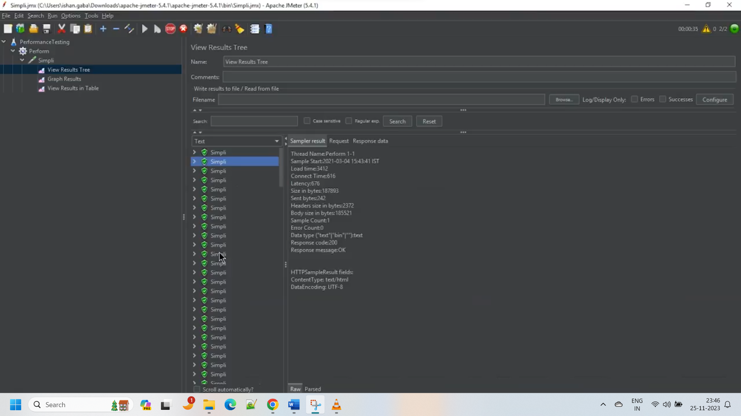

Load Testing in JMeter:

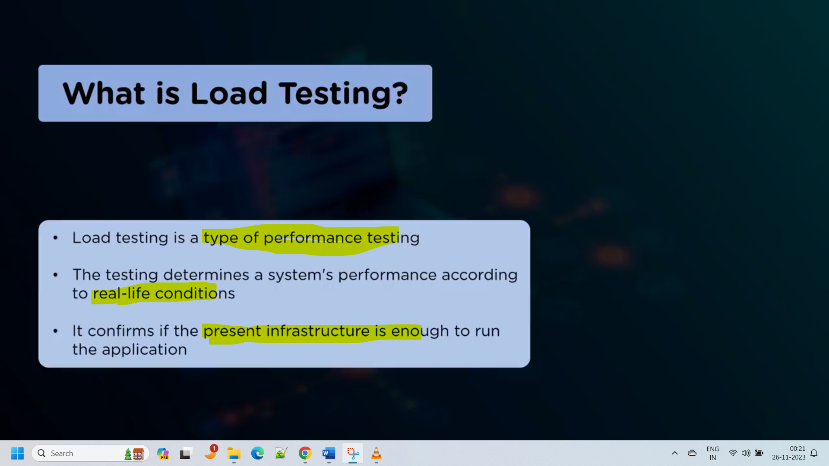

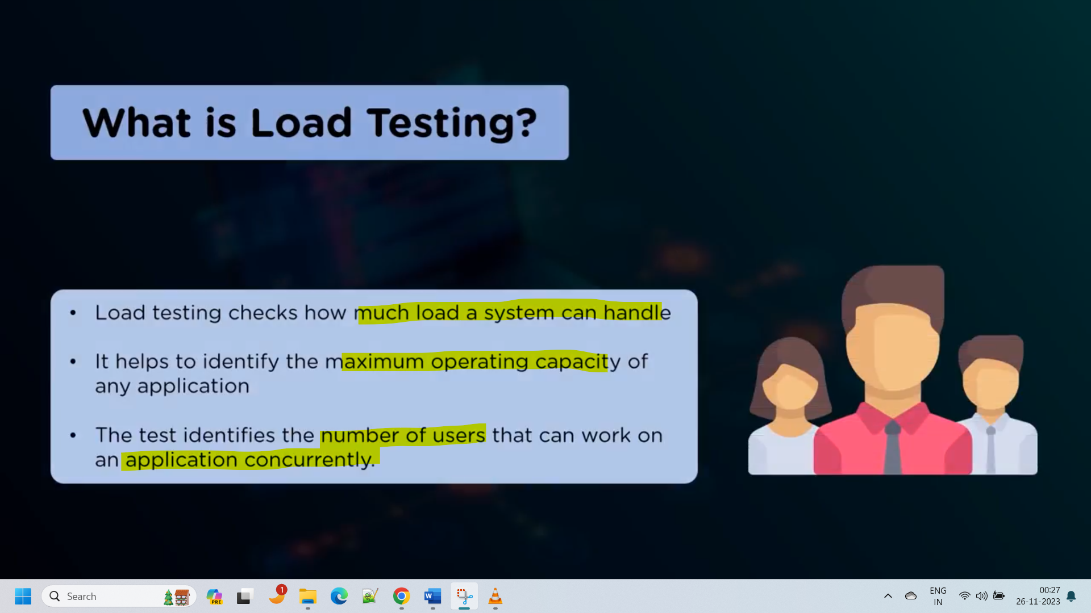

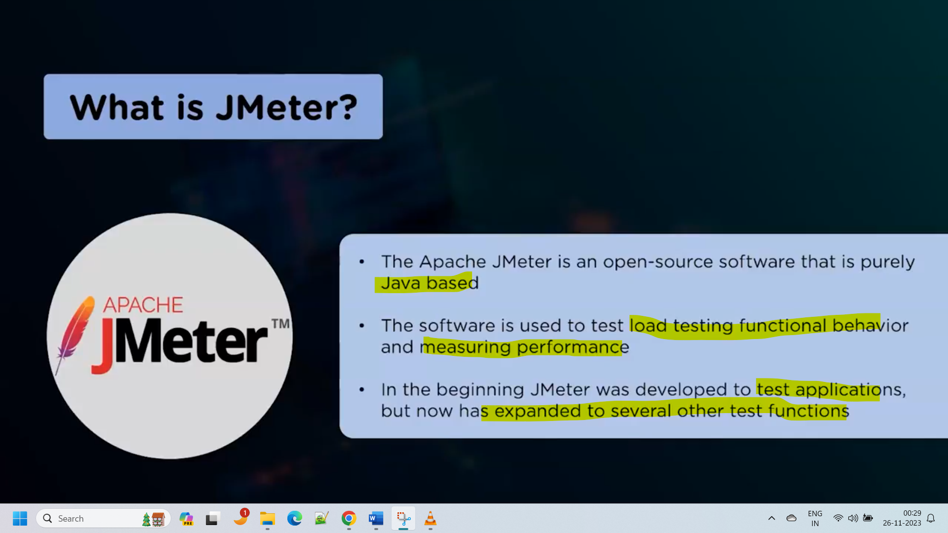

1. Open the JMeter from bat file.
2. Create new test plan
3. Add the thread group
4. Add the http sampler for different pages

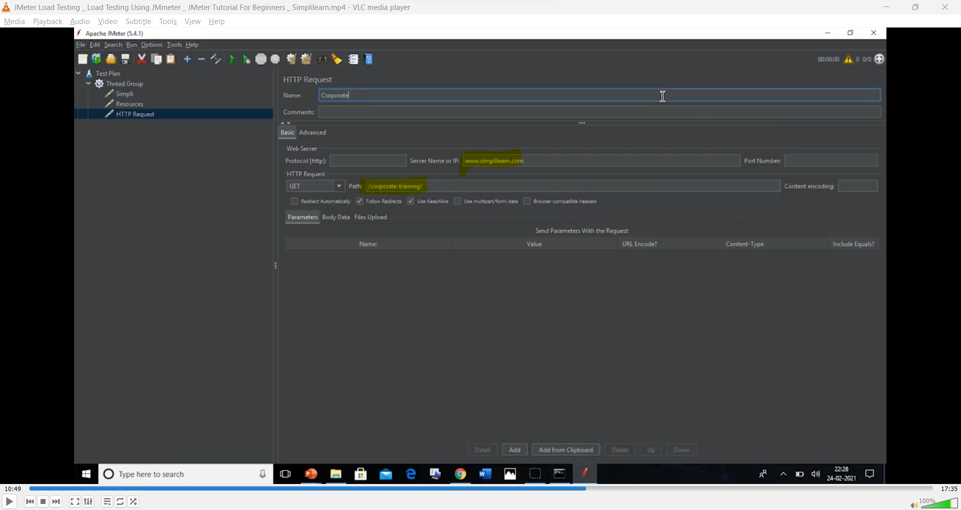

Here we’ve added 3 samplers for different paths.

1. Save the file with .jmx formet.

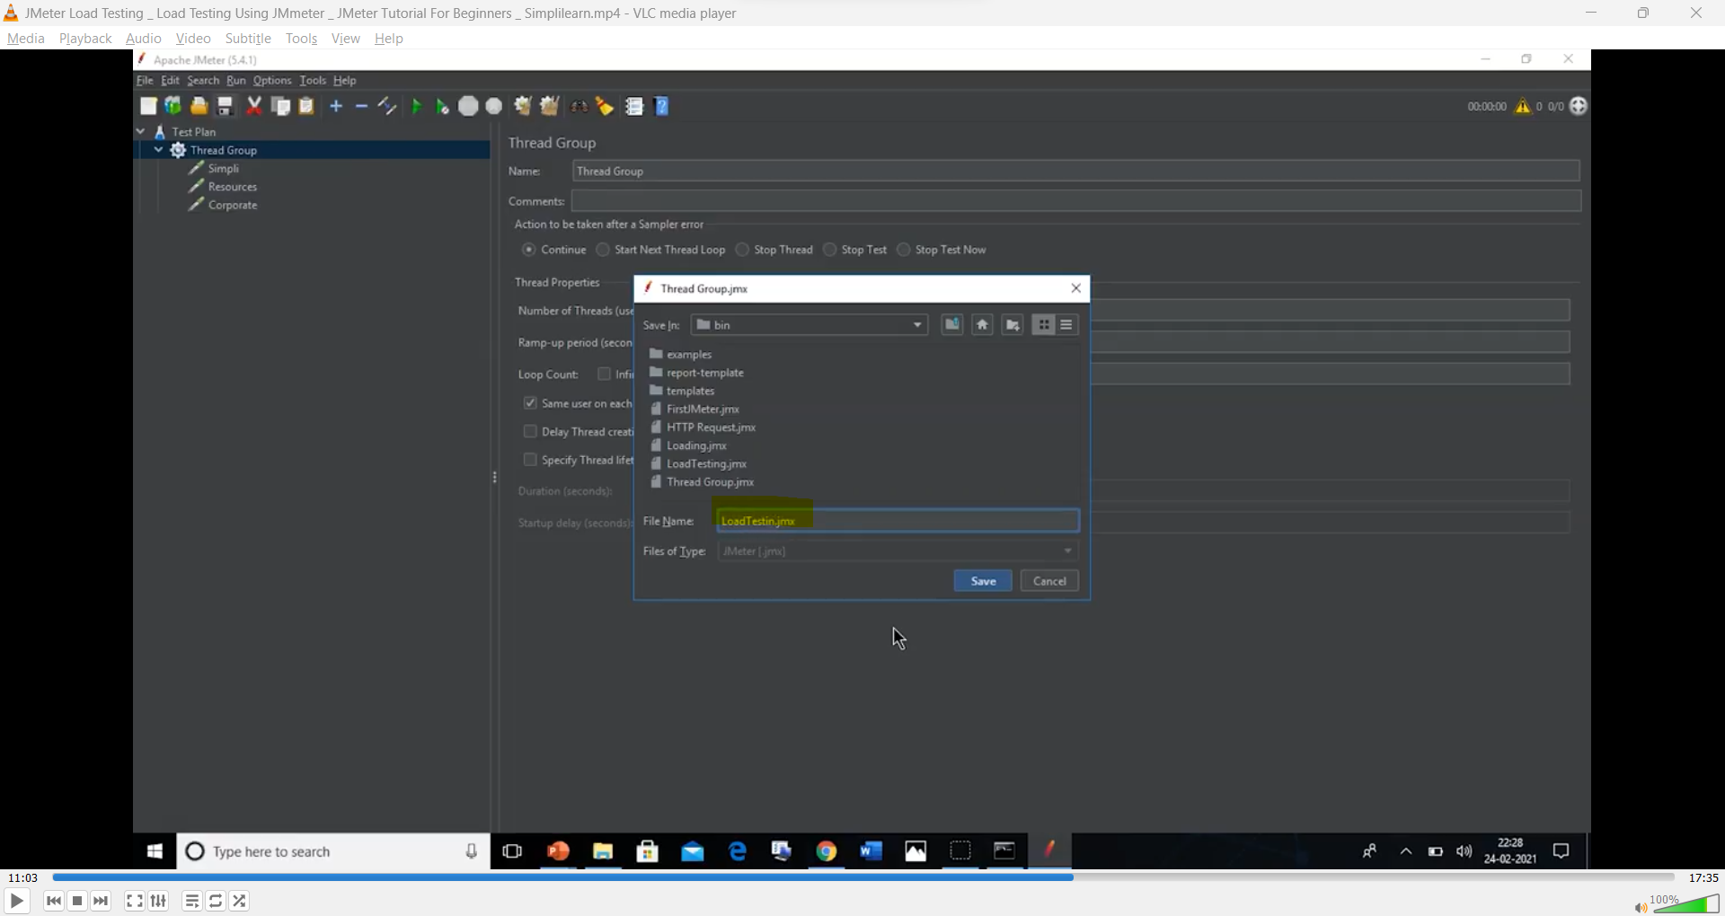

1. Add the required listeners

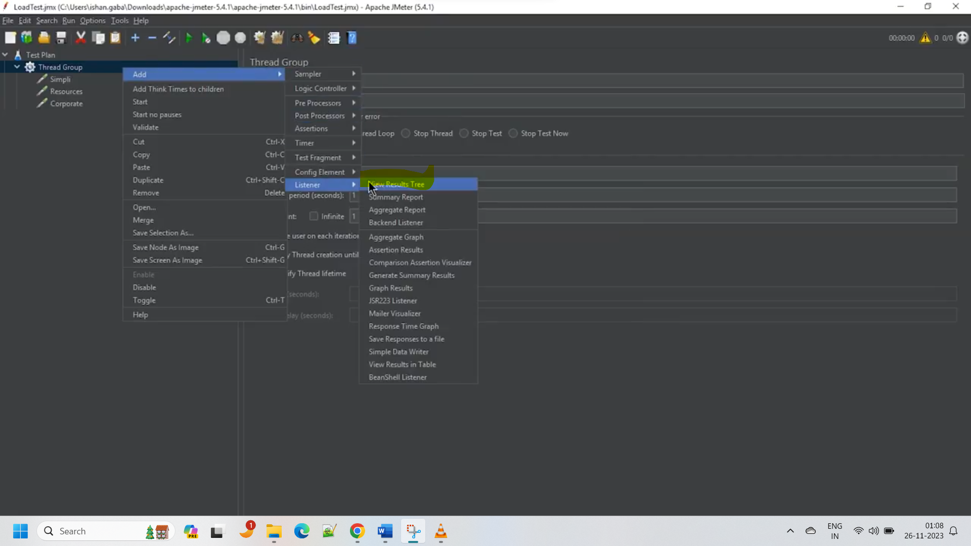

1. Run the test
2. Now increase the users in thread group and loop to 10

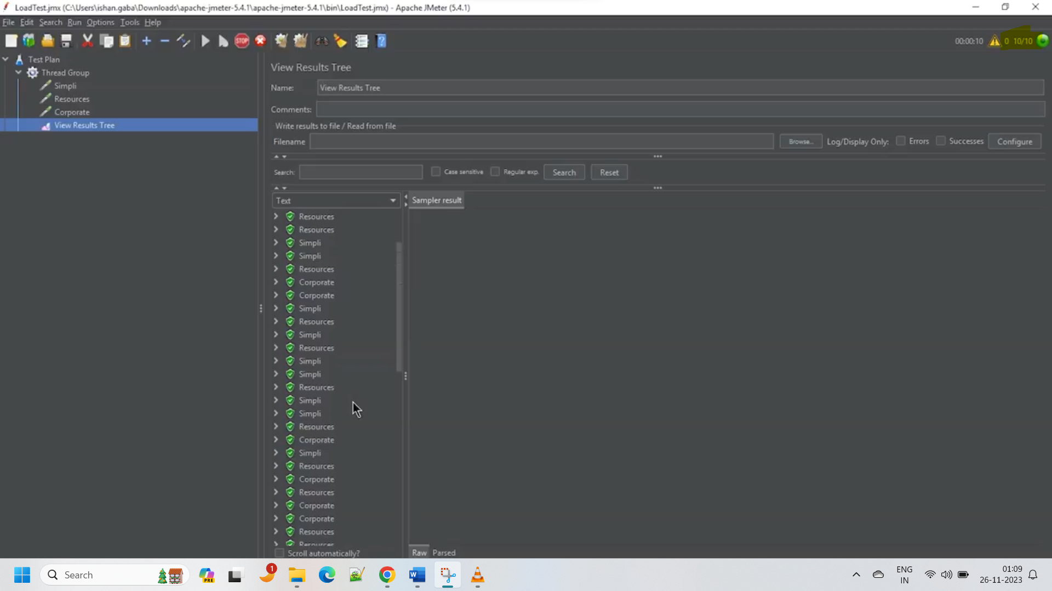

1. As we’re using Jmeter UI to run the test it’s known as Graphical user testing.

Running the created test using command prompt.(Non Graphical user testing):

1. Create the csv file in the source folder to store the results in csv file.
2. Execute the below command to run the .jmx test file.

Move to JMeter bin folder using cd.

Jmeter -n -t filePathOfTheTestFile.jmx -l sourceFilePathToStoreTheResults

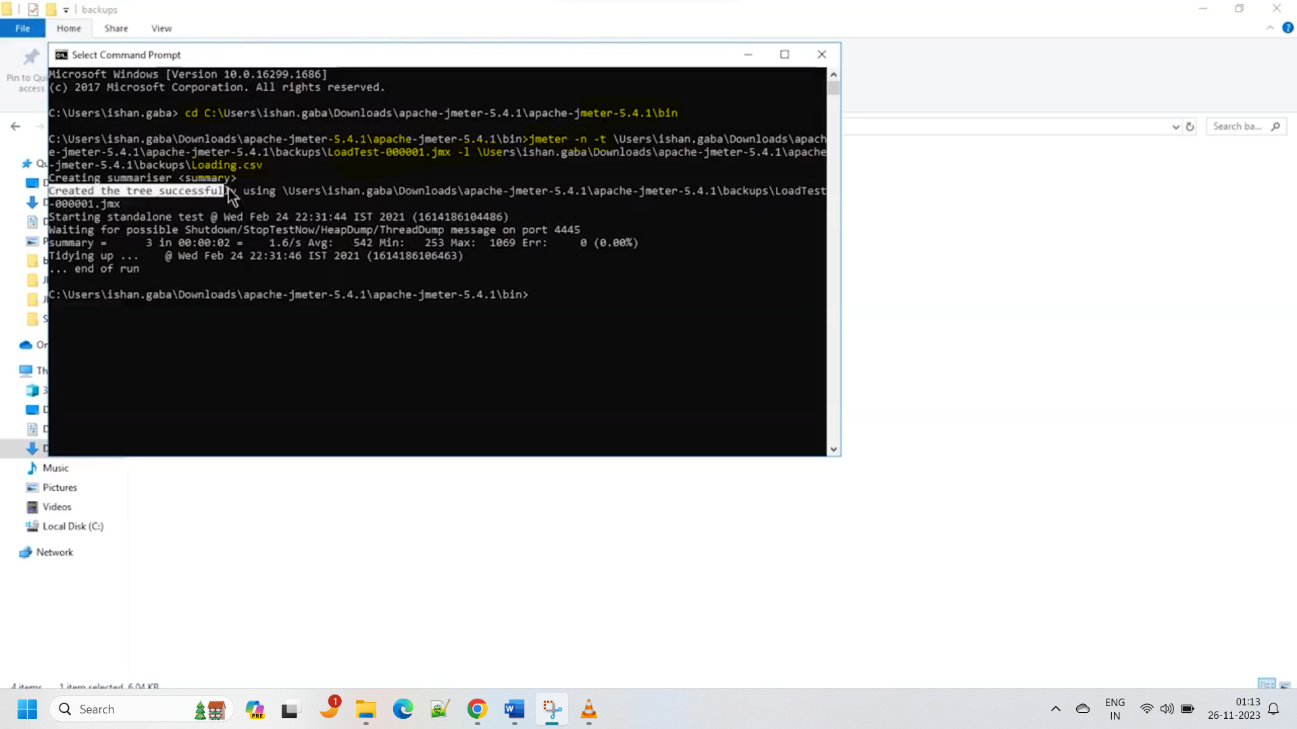

1. The results will be stored in the specified csv file.

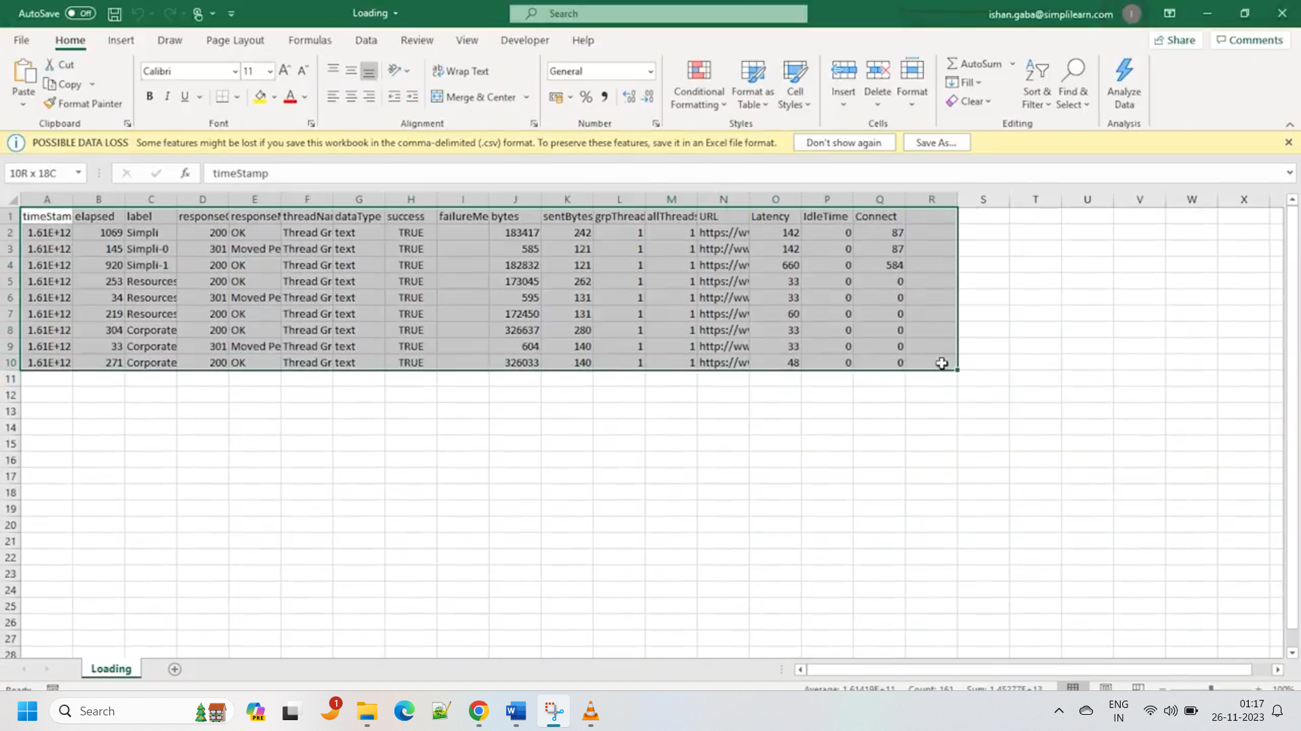

We can also use the dashboards to represent the responses.

API performance Testing using JMeter:

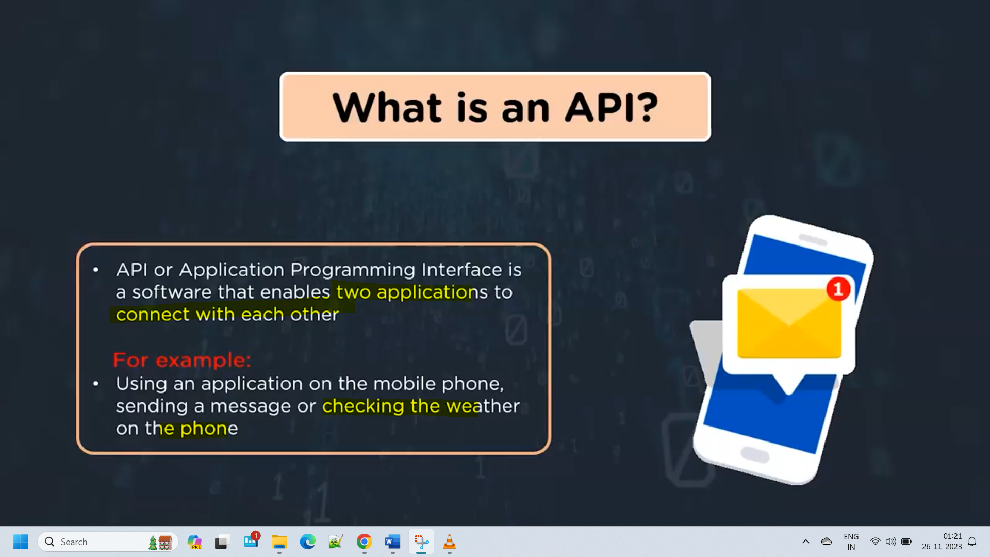

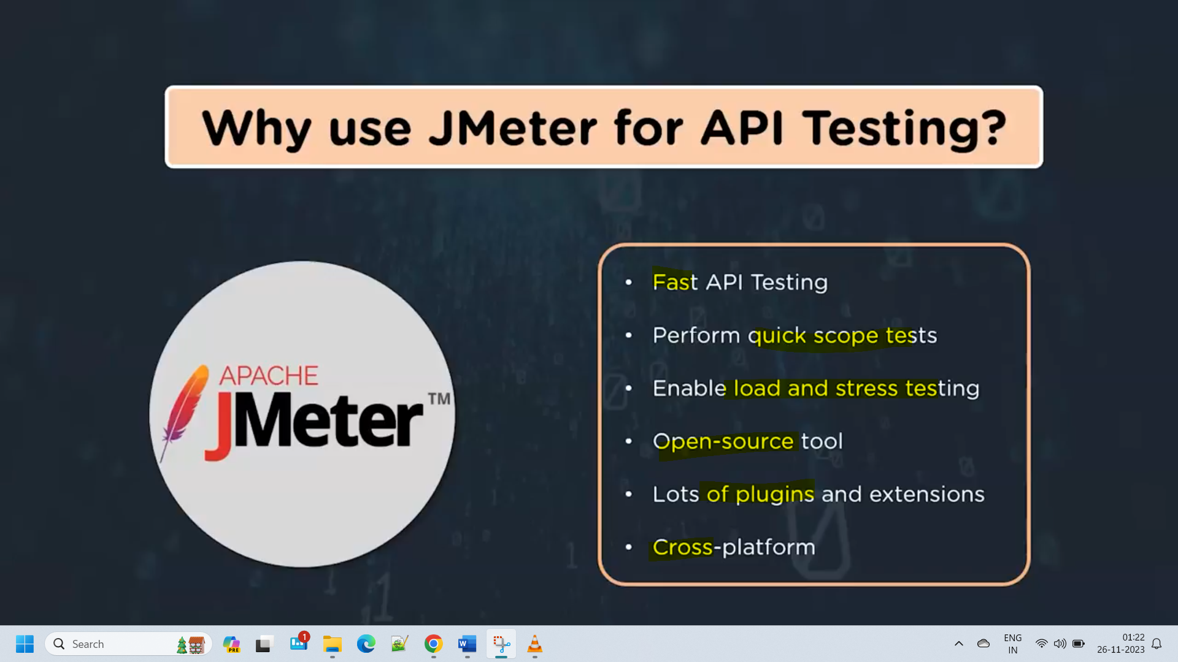

API testing:

1. Open the Jmeter and add the test plan
2. Add the thread group(users)
3. Take the sample API from reqres.in portal

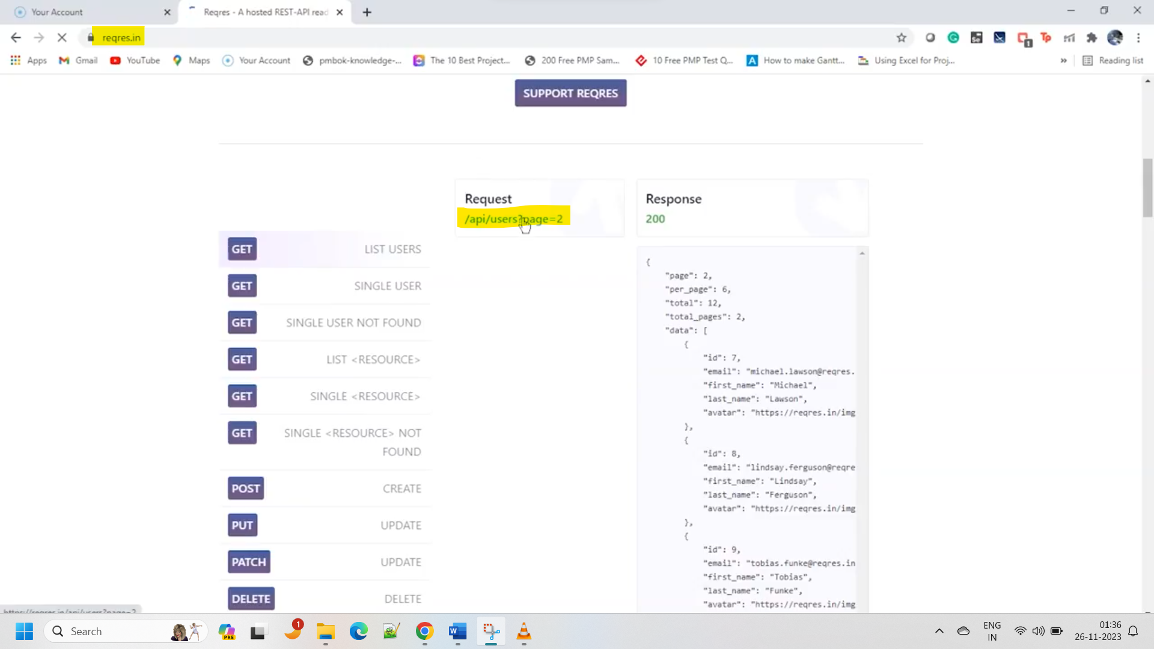

1. Add the http request sampler

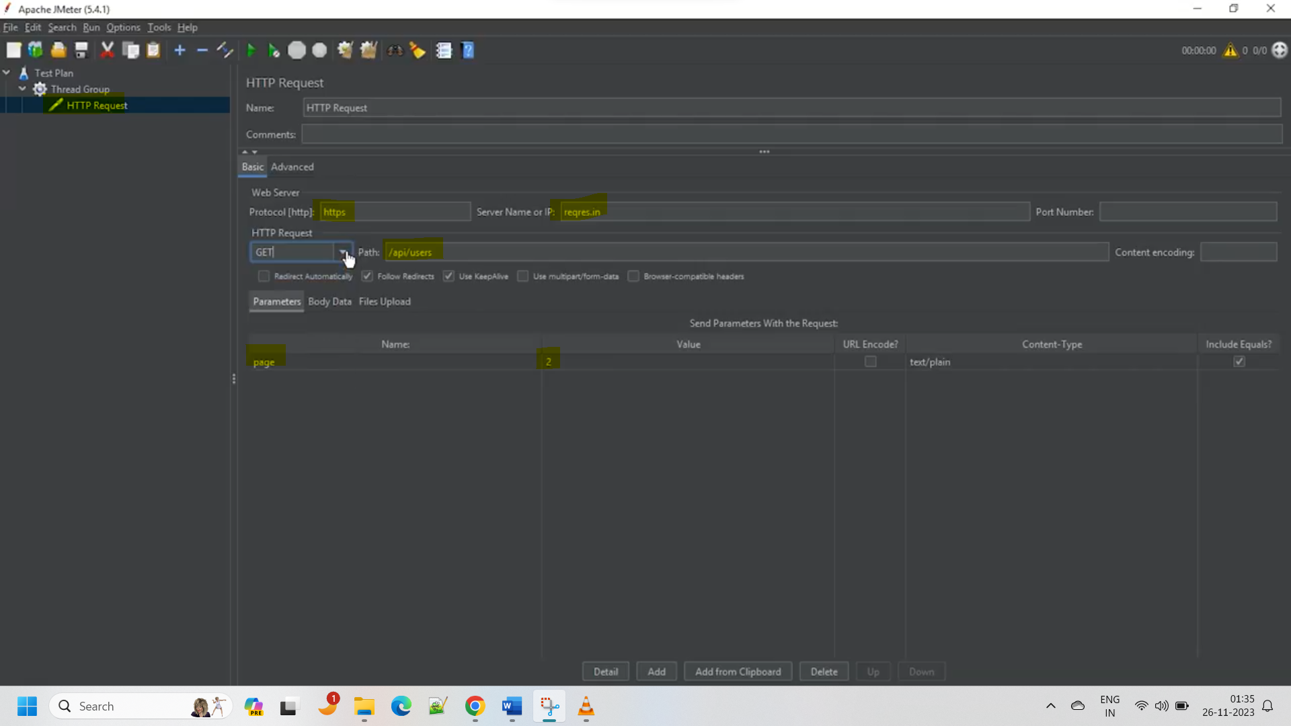

Here the API is : <https://reqres.in/api/users?page=2>

Add the path in path location(everything after the /)

Add the parameters into parameter section(everything after ?)

1. Add the listers to view the response
2. Save the test with .jmx formet.

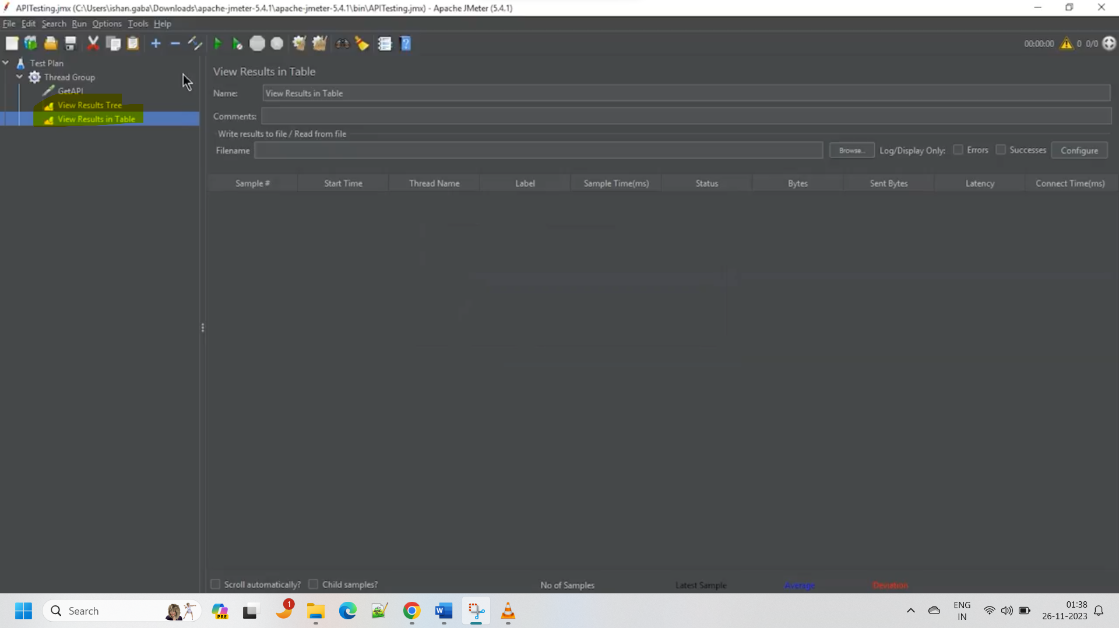

1. Run the test and view the responses.

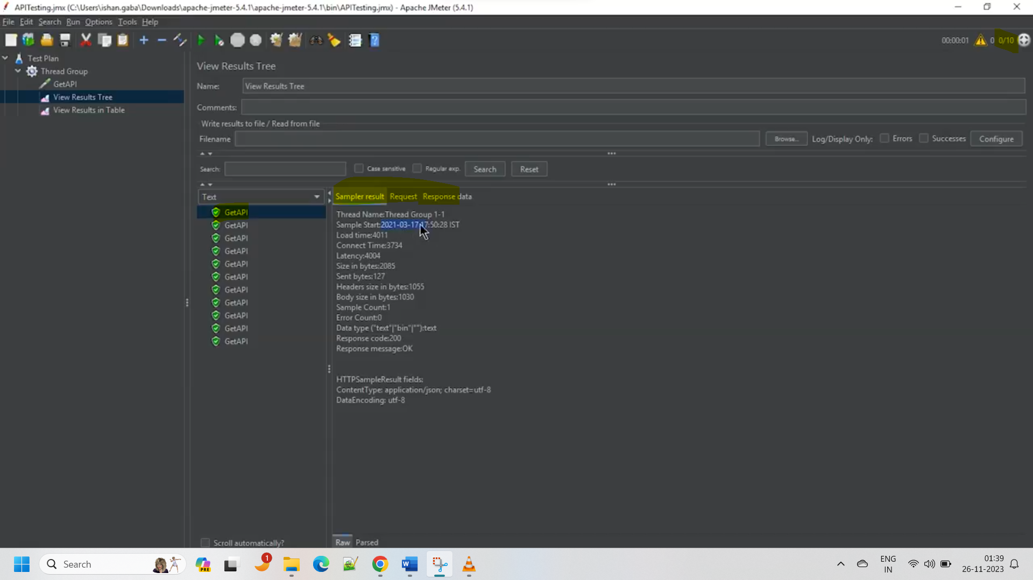

1. Api test for GET req is success.

Similarly we can perform the API testing for different methods like POST,PUT, etc

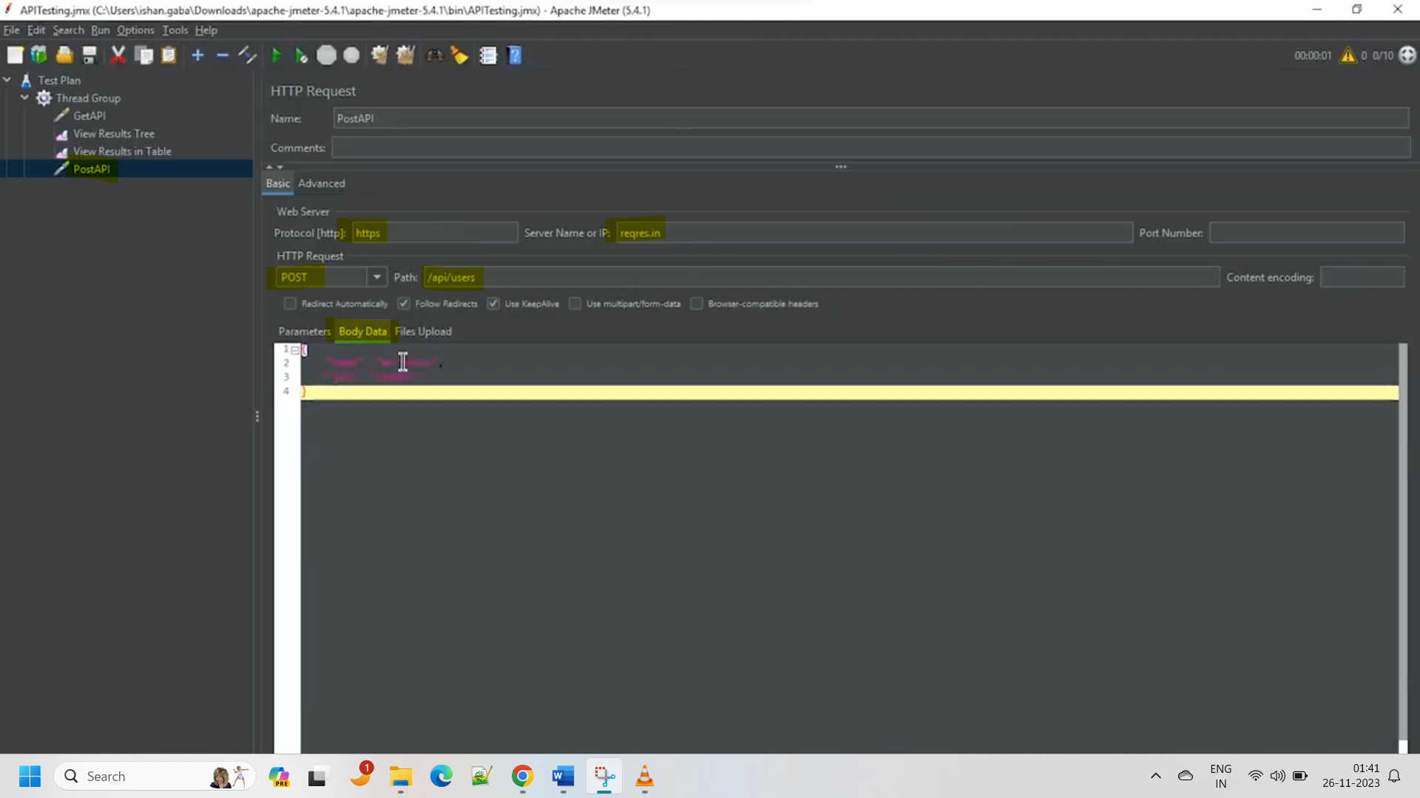

Add the next POST request sampler and make sure to clear the previous response before running the current test.

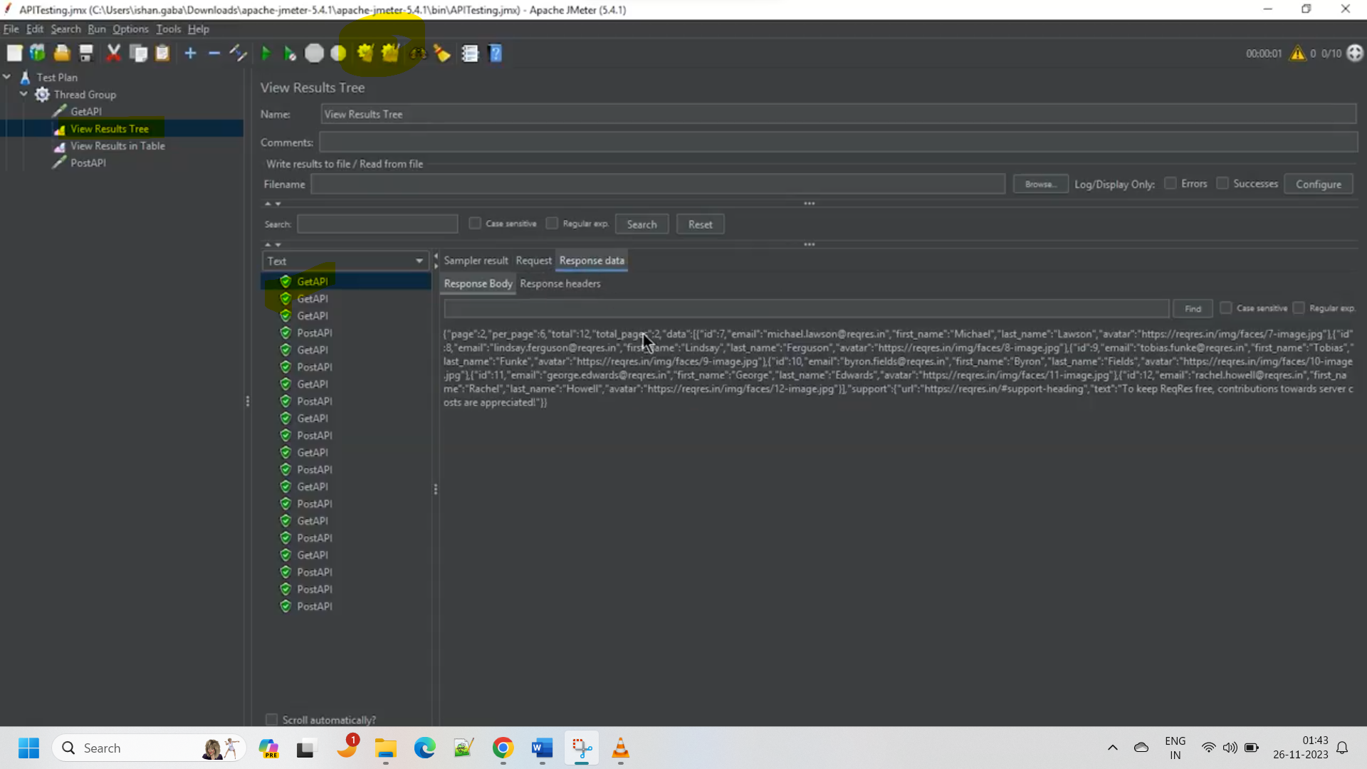

You can use same listers for all the samplers in the thread group.

Same procedure for PUT req also.

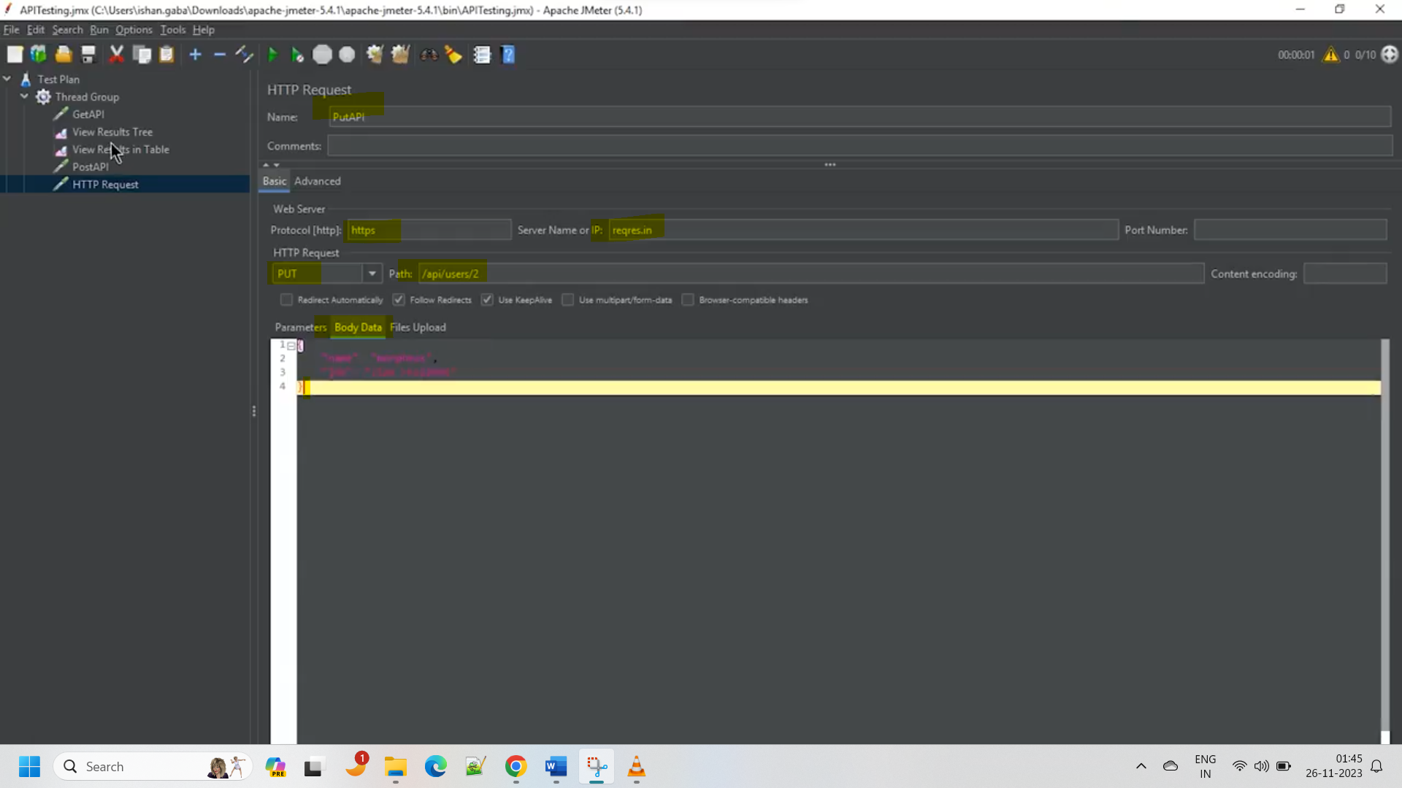

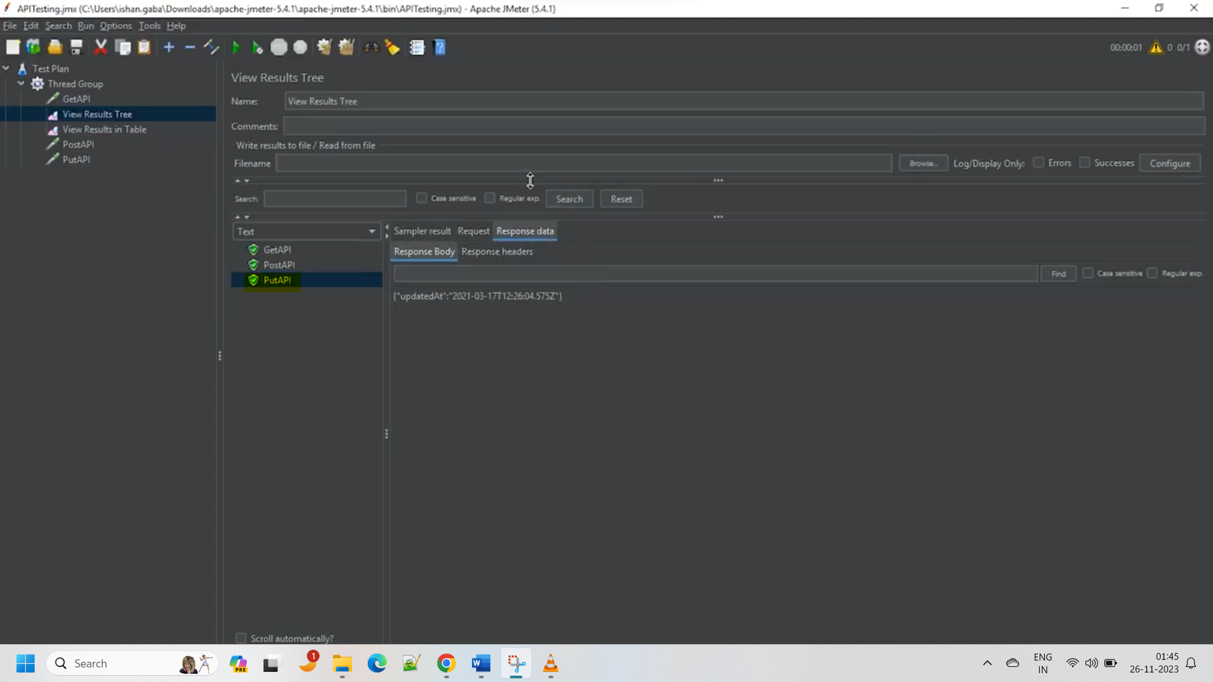

Same for DELETE method also:

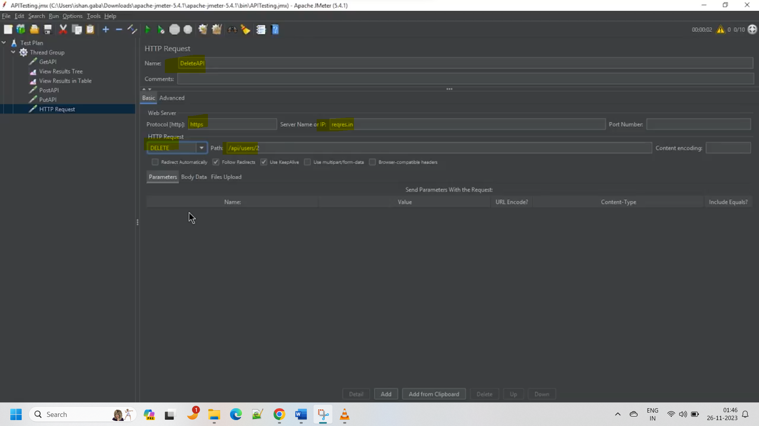

In my PC I’ve installed the JMeter in below path:

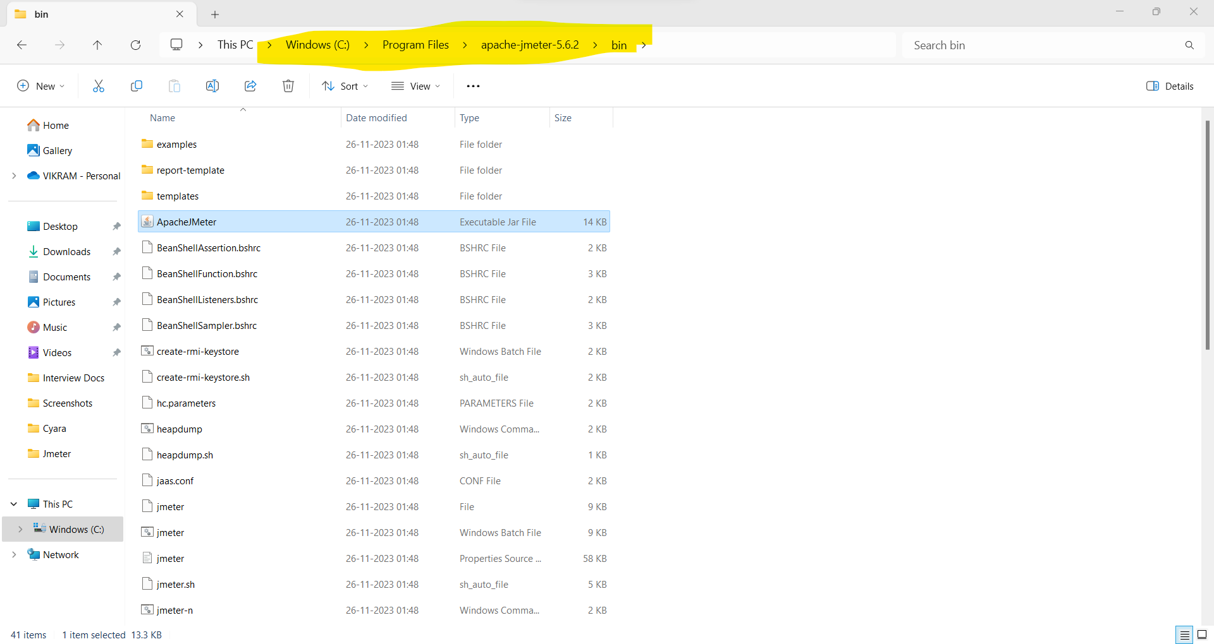

You Made it Again and Again Vikram!! Keep Rocking!